Bed Time Stories: Creating Puddin Wuddin

Natalia Golden
B00539273

Bdes Design and Communications DES 518

3rd of May 2012

Abstract

This report documents the process of creating a book for young children. Throughout the paper we go through the different methods and stages we went through in order to make our final piece. In one section we talk about the artists who inspire our work and influenced the project. There is a summary of our experimentation in order to find the right style of illustration for the finished book. We also talk about writing our story book and the storyboarding techniques we used when creating the final product. There is a section dedicated to our character design where we go through the procedure step by step to show how we achieved our final characters. This is a detailed report covering the development and creation of a children’s bed time, story book.

1. Introduction

The final assignment of our degree was left completely open for us to decide what route we wanted to go down. We were free to design something that we felt truly passionate about. We decided to write and illustrate our very own story book for young children. It was decided that we would create a group of new characters and a new story that young children could relate too and love. We created Puddin Wuddin, a cute, adorable, little reindeer. Puddin’s story a sweet and innocent tale of two friends, (Puddin and his friend Timothy the Posh Penguin), who venture into a forbidden wood. In the woods they meet Titch, a snow cat, who they believe is a ‘monster’. When they get to know the little snow cat they soon learn that she is not a monster at all! The moral of his tale is simple: Never judge a book by its cover. This report goes through the process we went through in order to create this children’s book. Through the different sections we talk about the artists, illustrators and writers who inspired our work and who influenced us to go outside our comfort zones and try new techniques. We give a detailed account of our character design procedure and our experimentation with different styles and media to create our own unique style of illustration. This report is an account of the groundwork, development and final outcome of our project.

2. Background and Literature Review
Throughout this project we were constantly researching the work of different illustrators, artists and children’s writers who we found to be influential and relevant to our work. We studied the different styles, techniques and materials illustrators use when they are designing characters and scenery for children’s books. We also read books by well-known children’s authors. By doing this we were able to get an idea of what it is young children enjoy and what holds their attention when they are reading a book. During the whole of this project we studied many forms of art, design and literature. In addition to analysing illustrators such as Quentin Blake (Blake 2012), Shirley Hughes (Hughes, 2012) and Tony Ross (Ross, 2012), we also looked at the work of the artist Frida Kahlo (Kahlo, 2012), the animator Tim Burton (Burton, 2012), and sculptures by Lucy Casson (Casson, 2012). We read books by Roald Dahl (Dahl, 1975) and watched short animated films by Walt Disney (Disney, 2012). In this section of the report, we will talk about the vast amount of ideas and inspiration we gained from the different artists, illustrators and writers work that we have studied.
One illustrator in particular who had a huge impact on this project was Quentin Blake, Blake (Blake, 2012). Over the years, Blake has gained a strong reputation for his recognisable and unique illustration style. It was Blake’s distinct and individual style of drawing that inspired this project. His line work is very loose and sketchy. The drawings look like they have being rushed. What we really liked about Blake’s work is the unfinished, scribbly lines and rough edges. Blake proves that illustrations do not have to have straight, clean cut lines. Scribbling freely keeps the drawings loose and interesting. The main aspect of Blake’s work that really influenced this project was his ability to capture a characters personality in his drawings. By simply looking at one of his character sketches, the viewer can immediately tell what sort of a person the character is. The viewer can tell the difference between a good character and a bad character just by looking at his work. For example, when you look at his character Danny, from the book “Danny Champion of the World”, (Figure 1) the observer can tell that he is a sweet young boy. The Twits (Figure 2), are two unpleasant looking individuals. The use of dull colours makes them look grubby, untidy and unfriendly.
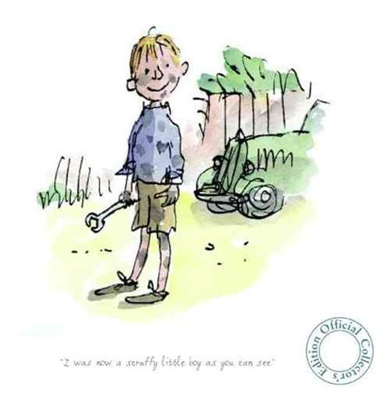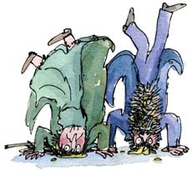
Fig. 1: Danny Fig. 2: The Twits
Blake is best known for his work with the famous author Roald Dahl. Roald Dahl once said that: "There's no-one to touch (Blake). He has a magic gift of drawing a character on the page exactly as you imagined it." (Blake, 2012)
Blake influenced us too go outside our comfort zone. Instead of creating characters that are stiff and lifeless, we loosened our pen work and allowed the lines to be sketchy and free. This gave us characters with movement, life and personality.
Another artist who has a very distinguished style of work is Tim Burton (Burton, 2012). He is known for his strange illustrations and unusual characters. Similar to Blake, Burton has a very loose, scribbly style. Burton tends to have very eerie and weird drawings. His characters are often strange looking people. They have pointy, ghoulish features and elongated, skinny bodies. His drawings express a lot of emotion. For example, (figure 3) one can sense Mummy Boys disgust and annoyance when the character of Voodoo Girl is screaming. Although these drawings are simple, the emotions portrayed are very effective. This makes them more realistic.
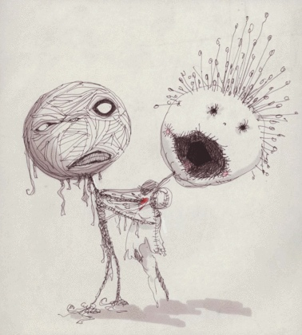
Fig. 3: Mummy Boy and Voodoo Girl
By reading children’s books we were able to get an idea of what sort of stories children like to read and what keeps them interested in a plot. We read Judith Kerr’s “The Tiger who came to Tea” (Kerr, J. (1973), The Tiger Who Came To Tea), “Horrid Henry” books by Francesca Simon (Simon, F. (1997), Horrid Henry's Nits), Shirley Hughes and her “Alfie” books (Hughes, S. (1997), Alfie Gets In First), and Roald Dahl’s “Danny Champion of the World”. Each writer has his or her own individual imagination and writing style. One author in particular stood out from the rest and her name is Shirley Hughes.
Shirley Hughes has become one of the best loved illustrator and writer for children. Over the years Hughes has wrote over fifty books which have sold millions of copies. Hughes writes stories about simple, everyday things that children experience such as getting up in the morning and going shopping. Her stories are true too life and relatable. Hughes has a signature illustration style. She is exceptionally good at drawing children. She has created some of the most memorable and loved characters and stories for young children. She captures their youthful features perfectly adding little details such as red, chubby cheeks and pudgy little bodies. She captures their energy through her beautiful, brightly coloured illustrations. Her work shows how important it is to have characters in a book that children can love and relate too.
Hughes once said: “When I am working on a book I am running on two tracks- controlling the technique…and at the same time inhabiting my characters. Even very small readers can develop a strong loyalty to fictional characters once they have taken them to heart.” (Hughes, 2012)
Her story relies very little on her text, she tells her stories through her pictures. A perfect example of this is the book “Alfie Gets in First”. In this story, Alfie runs home ahead of his mother to get into the house first, (See right side of figure 4). The reader can feel Alfie’s excitement as he gets too the house. Her work is so alive reader can feel the door slam shut as he closes it, (See left side of figure 4). Hughes is an innovative and influential author and illustrator. Her use of simple language and powerful imagery inspired this project greatly. Hughes shows that you need very little text and a strong illustration to tell a good story that will entertain young children.
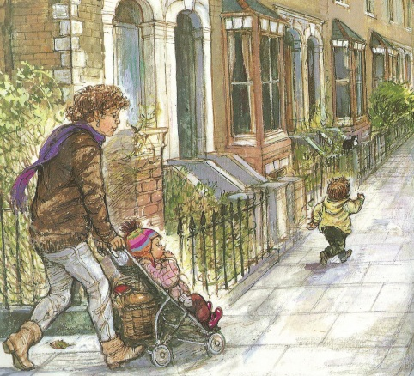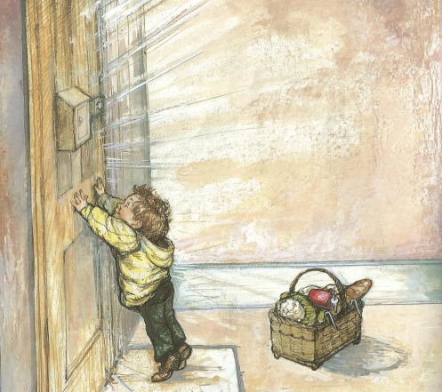
Fig. 4: ‘Alfie Gets In First’
One of the most important aspects of this project was our character design. We wanted to create a new group of likeable characters that would appeal to young children. We decided to look at work by Walt Disney. Over the years Disney has entertained both children and adults alike. Disney has worked on a wide range of animated feature films and shorts. They have created some of the most memorable and loveable characters for children such as Mickey Mouse, Donald Duck and Goofy. We also looked at the work of Nick Park (Park, 2009) and Aardman Studio’s (Aardman, 2012). Nick Park is famous for his characters Wallace and Gromit. What we love about Parks work is the simplicity and plump form of his characters. His characters look friendly and loveable, which would appeal to a young audience. Another children’s character we looked at was the “Pingu” (Pingu, 2012). Pingu is a very cute and mischievous penguin. He has a round, chubby body with very simple features, all of which make him a good character for the young admirers.
An interesting artist who designs her own unique little characters is Lucy Casson. Casson builds sculptures using unwanted, recyclable items she finds on the street outside her art studio in London. She has being known to use materials such as wood, plastic, tin cans and bits of scrap metal to create very cartoon like figures. She has an eye for creating quirky characters. Her figures are very animated. They have mouse like features and stringy arms. Her creatures all have very similar features. They are recognisable and look like they are all form the one family. Although they all look more or less the same, Casson gives each individual character a personality and a role to play in her beautiful hand crafted scenes (Figure 5). Her style and imagination influenced this project greatly. She inspired us to be a little bit different when designing our own characters.
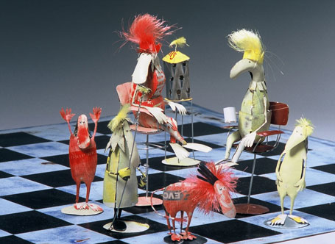
Fig. 5: Lucy Casson

3. Character Design
Getting the right characters was extremely important for this project. We wanted to create new, original characters that would appeal to young children. We created three main characters that we feel children would love. Each of these characters has their own unique personalities. They are all very different from one another but they are all very adorable and captivating in their own way. In this section of the report, we will introduce the characters one by one and go through their individual design process.
The inspiration for the main character came from a child’s cuddly toy. The toy was a small, rounded, reindeer teddy bear that was bought in Tesco (Tesco, 2012). The teddy is quite an unusual and awkward looking shape. He has small arms and short legs which don’t allow him to stand up on his own. His facial features are very cartoon like and minimal. He has a big, round nose and two small, beady, black eyes. His body is shaped like a Christmas pudding so he was named ‘Puddin Wuddin’. His simple features and circular body make him very likeable and cute. He has all the characteristics to be an appealing and well loved children’s character. With his basic features and simple form, we could easily adapt him into a cartoon like illustration for a children’s story book.

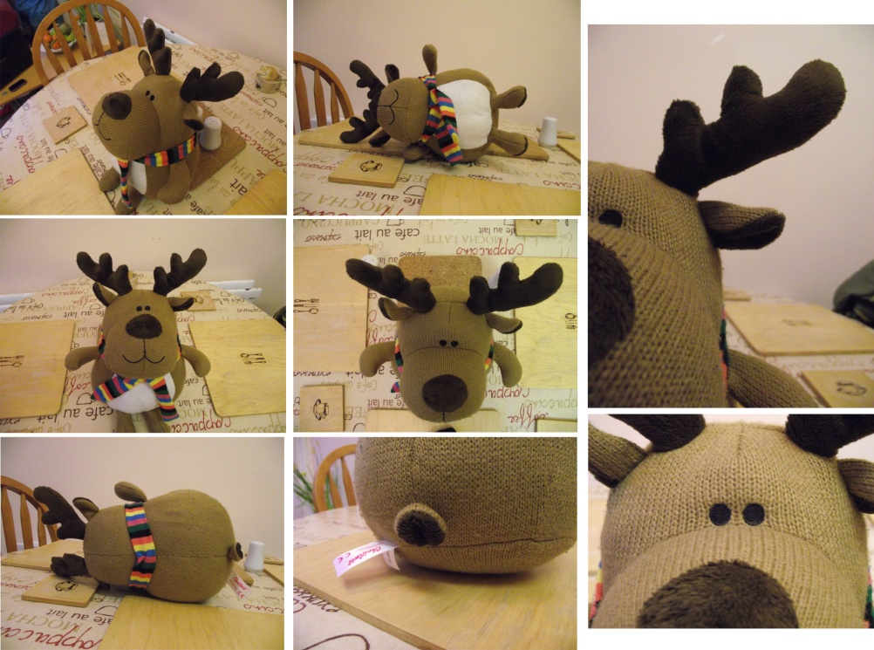
Fig. 6: Observation Photographs
The design process began by photographing the toy version of Puddin Wuddin, (See figure 6). We photographed the model from different angles and positions. We took close up photographs, side view, front view, back view, etc. This allowed us to get a better idea of the toys form and shape. Once there was enough photographs gathered the observation work really began. We carried out a number of sketches from the photographs, (Figure 7). By doing these sketches we got a better understanding of the toys overall form. Also it gave us a better idea of the toys features and what ones we could keep when it came to designing the finished character for the book.
There were quite a few of the toy original features that made him very loveable. These features were the teddy’s egg shaped body, his small, circular, black eyes, his big, round nose and his antlers. It was felt that these features in particular would be excellent to use for the final character. Some are very simple and basic, such as his eyes. Other features are exaggerated like his nose that takes up the majority of his face. His pudgy body makes him look cuddly, which will appeal to young children. He looks cute, loveable and huggable. We did not want to change too much of our original model when it came to making our character. The only aspect of the model that really needed changing was the characters arms and legs as they were far too small. They do not look like they are in proportion with the rest of his body.
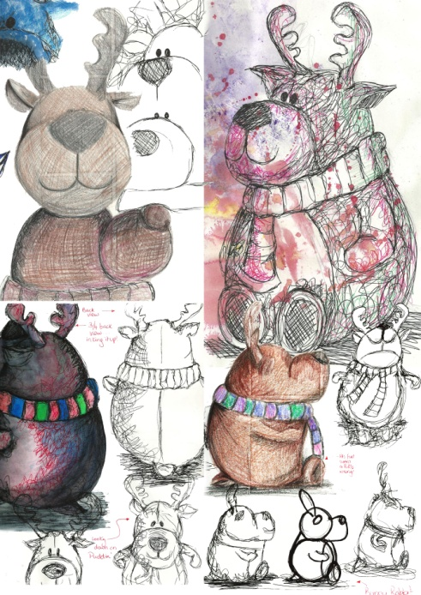
Fig. 7: Observation Sketches
The character design process for Puddin Wuddin began by keeping the original model in mind, but modifying certain characteristics and limbs. We went through a lot of different Puddin designs. Some of the designs were short and round. Others were elongated and skinny. It was a long process to get the right character. The final design stayed true to its original counterpart. His body was kept round and plump. The shape we used to create his tummy was like a tear drop. It was narrow at the top and it gets wider down the bottom and curves. The smallest part of the tear drop is at the top and this is where Puddin’s head goes. The other parts of his body are then added on to the body afterwards. We kept the reindeer dolls small, emotionless eyes. This would allow Puddin to express his emotions by using his body language rather than just his eyes. We also kept his big nose and antlers almost the same as the dolls. It was decided that the illustrated version of Puddin would be able to stand and walk about the place. We gave him longer legs with two big, rounded feet, with no toes, which would allow him to stand upright. We gave him longer arms with mitten shaped hands, (no fingers, just a thumb), to keep them simple and similar to his feet. The main aim was to create a character that was likeable. We wanted our character to be sweet, cute and innocent, similar to a young child. With Puddin Wuddin we feel that we have achieved that goal. His overall appearance is adorable and would appeal to children, (Figure 8).
We wanted Puddin Wuddin’s personality to be as appealing as his appearance. Puddin looks soft and friendly. Like all deer’s, Puddin too would have a quiet and timid nature. His main personality trait is his nervousness. He is a bit of a coward and shies away from anything that he considers to be frightening or dangerous. We began to draw Puddin Wuddin expressing a range of different emotions such as happy, sad, angry, and excited and many more. This allowed us to see what Puddin would like when he was expressing his feelings (See figure C). We choose a number of different emotions and then they were assigned to Puddin’s face. Depending on the emotion, we would change the shape of Puddin’s mouth from a happy to ecstatic, ecstatic to frightened, and so on. We would also change the shape of his antlers. For example, when Puddin is happy his antlers stand upright on his head. When Puddin is sad his antlers turn downwards.
Puddin was also drawn acting out a number of different actions and movements. Some of these poses Puddin was waving, looking up or down, walking, running or standing on his head. By doing this, we were able to see how Puddin would look if he had to perform such actions in the story. It also showed us how flexible the overall character design is. We are very pleased with the final Puddin Wuddin design. We believe that he is a loveable and cute character that would appeal to young children. He is still very much like a cuddly toy. His plump appearance and timid personality makes him a very cute and loveable little reindeer.

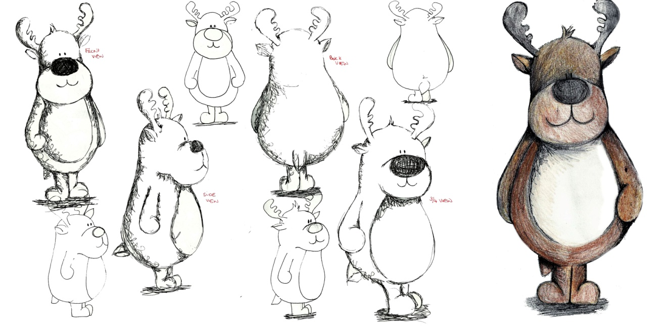
Fig. 8: Final Character Design
Puddin Wuddin needed a sidekick. We created Timothy the Penguin to be the little reindeer’s best friend. Timothy is the opposite of Puddin Wuddin. While Puddin is gentle and timid, Timothy is always up to mischief and getting the pair into trouble. Timothy is cheeky, inquisitive and he is always getting to pair into trouble. Timothy’s main role in the story is to make Puddin do all the things he is afraid of. Timothy makes the story interesting. Timothy and Puddin bring out each other’s character traits to make a more exciting and humorous tale.
The design process for Timothy was much the same as Puddin Wuddin. Once again, we began the procedure by photographing a small toy bird that was a similar shape to the other toy. It was plump and round, it had short arms and legs, and it also had two small, black, beady eyes. We photographed the toy from different angles to give us a better idea of its form and features. Afterwards we began the observational drawings, (Figure 9). This allowed us to pick and choose what aspects of this model that we liked and may keep when we are designing the character for the story book.
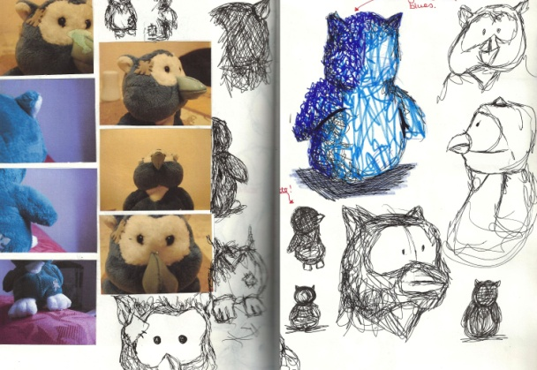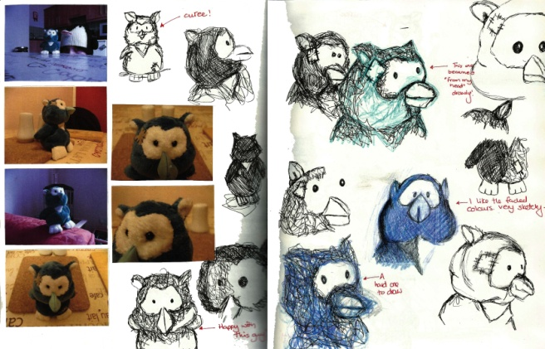
Fig. 9: Timothy Observation Work
Timothy proved to be an easier character design compared to Puddin. We reused the teardrop shape to form Timothy’s body. This makes him appear plump, snuggly and loveable. Instead of giving Timothy legs we just gave him two feet; too make him shorter than Puddin. Instead of arms, Timothy has two pointed wings that hang down by his side. His facial features consist of two black eyes and a red beak, (Figure 10).
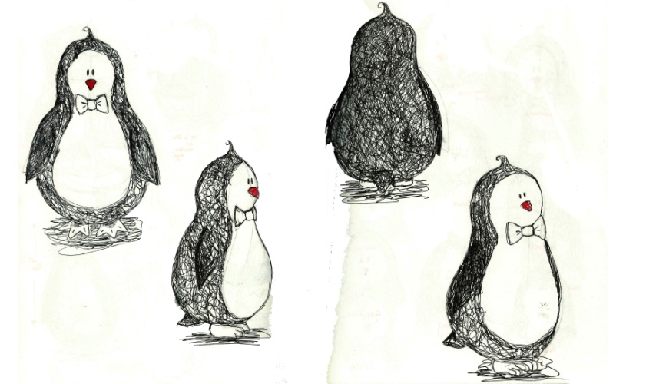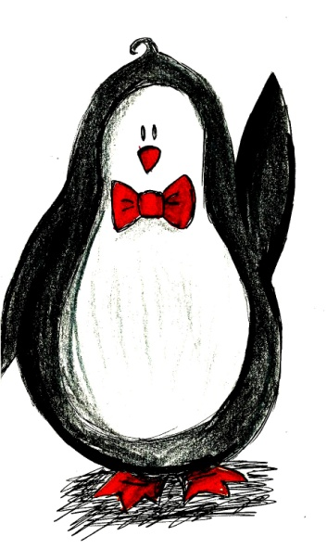
Fig. 10: Final Character Timothy
One difficulty with Timothy was his lack of facial features.The only way we could get Timothy to show his emotions was by opening and closing his beak (See figure E). His expressions depend on his body language, for example if Timothy is sad, he would hang his head and his beak would turn down. If he is really happy or excited he would have his arms in the air and his beak would be an open smile. Another problem we discovered with this design was that we were quite restricted with the amount of foot movement Timothy could have. He was less flexible than Puddin. In order to make Timothy look like he was walking or running we would have to exxagerate the movement of his feet. We drew Timothy doing certain actions that he might have to carryout in the story. We did sketches of him waving, walking and jumping, (Figure 11).
Timothy has a very important part in the over all story. With out him there would be no adventures. Timothy’s main role is to get Puddin to do all the things that he is frightened of doing. This provides both humour and excitement in the story. It will keep the young reader interested to see what idea Timothy will have next and where will he bring poor Puddin Wuddin too this time?
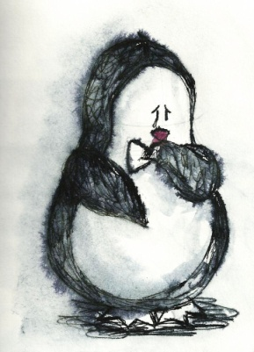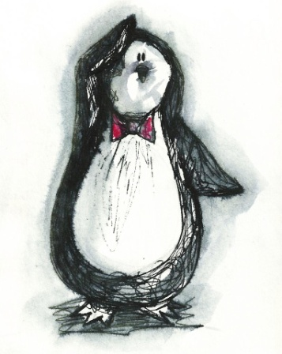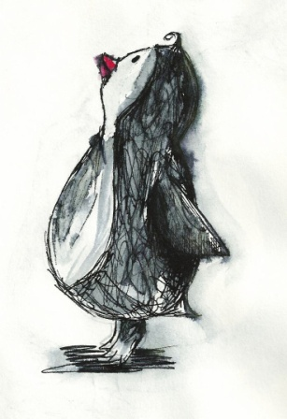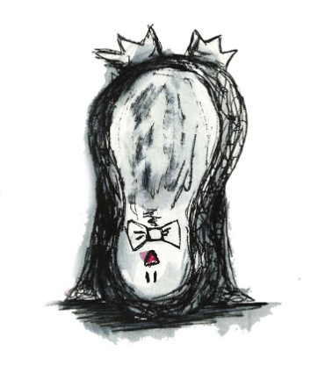
Fig. 11: Action Poses
The final main character of the story is Titch. Titch is a female snow cat who lives in the da, dark, wood that timothy and Puddin are warned not to enter. Of course, the pair go against these rules and go into the woods where they meet Titch. Titch is the only girl character in the story who has a major role. We wanted to play on her girly qualities through her appearance and personality. Titch is a giggly, cute little girl. She is playful, energetic and a little bit sensitive.
Designing Titch was a little bit different than the other two characters. Instead of using a soft toy as the model, we used a real cat. The cat was followed around for a couple of days with a camera and his movements and poses were documented. While it was hard to get the cat in static poses, we managed to get quite a good few photographs of the cat walking around, eating and cleaning itself. This was an excellent way to document and understand the cats pyhsical form. When we started the observational sketches, drawing from a live model was much more difficult than an inanimate model. There was a lot of trial and error during the observational work.
Again we used the teardrop body shape. Titch’s body shape is close to that of Puddin Wuddin. Titch has two legs and to arms. Her hands and feet are paws, similar to real cat. She has a long, bushy tail and a beautiful fur collar around her neck. She has two black pupils and rounded eyes. She has a small heart shaped nose and some eyelashes to add a girly touch to her physique. Titch’s face is quite expressive (See figure G). This made it easy for us to portray how she is feeling at certain points in the story. Titch adds a girly touch to the story. Her personality is girly, giddy and energetic. She is kind and loving. She teaches Puddin Wuddin and Timothy to never judge someone until you get to know them. She has big eyes and a cute little nose. Her overall appearance makes her an appealing character, (Figure 12).
The character design process was quite long and at times very difficult (See figures B, D, F ). We went through several different designs of each character in order to get the right one. Through our observation work, character design and final characters, we feel that we have created three original characters that young children will relate too and love. Each character has its own special personality traits and its own unique appearance. They are all very loveable and perfect for a children’s story book.

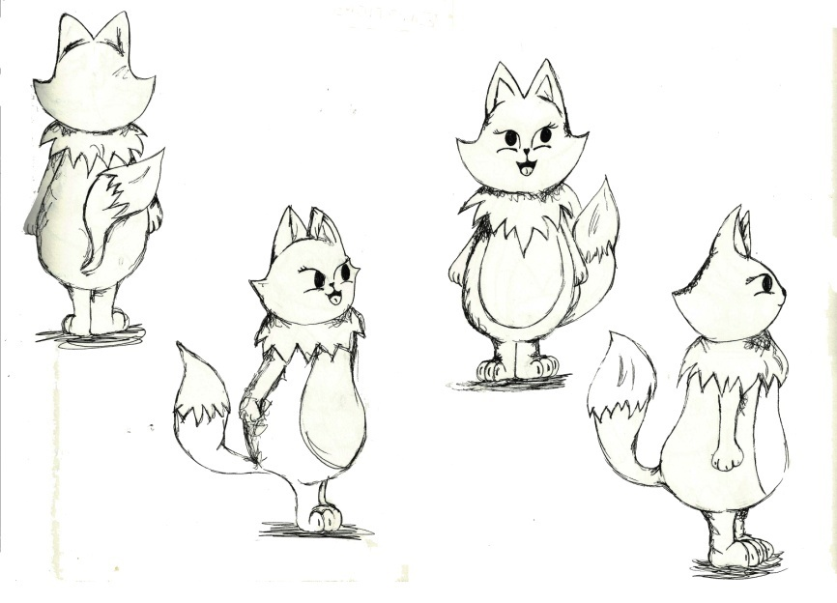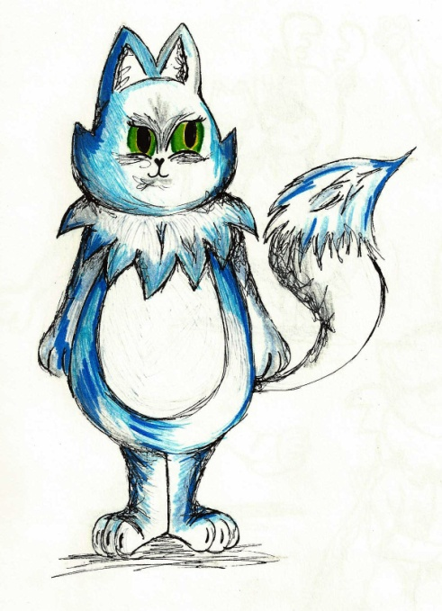
Fig. 12: Final Titch Design

4. Style
One of the important tasks of this assignment was finding our own individual style of illustration. From researching and studying the work of different artists and illustrators, we had a wide range of diverse styles and techniques we could experiment with in order to find one of our own. Finding a style was much more difficult than expected. It was all about trial and error and figuring out what style would best suit Puddin Wuddin and his story. In this section of the report we are going to go through the different methods and techniques we went through too come up with our very own unique style of illustration (See figures Hand I).
When we first designed Puddin Wuddin we made some rough, short comic book strips. Similar to the work of Simon Tofield, the creator of ‘Simon’s Cat’ (Simons Cat, 2012), we would give our comic strips a very short simple story with a hint of humour. These were simple line drawings with little or no detail. In one story Puddin Wuddin is climbing up on a table to look into a fish bowl. He is barely peeking over the table when he falls down on the ground landing on his bottom, (Figure 13). This was a very quick and effortless way to design our storyboards for the finished book. As a style it was not very satisfying. A child might find it dull and boring. There is nothing cuddly or welcoming about the character in this format, he is just a line.

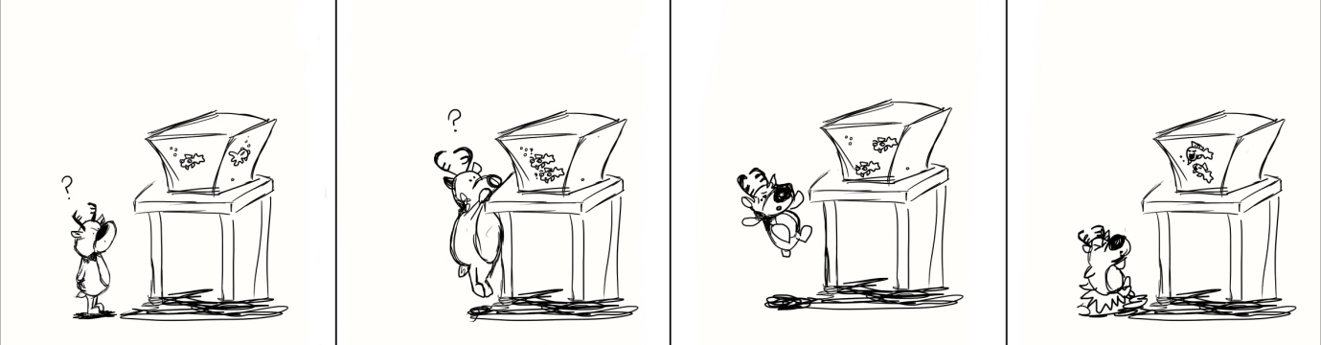
Fig. 13: Comic Strip
We began to experiment with different media such as paints, markers and inks. Calligraphy inks were the most satisfying media too work with. There were so many different ways we could use it. One technique we tried was using the inks like we would paint. We used blue calligraphy ink and water to create a portrait of Puddin Wuddin, (Figure 14). We only used one colour to keep things simple. To give the reindeer more detail, such as the shading, we would use less water and more of the inks. This made it more realistic. Although we were very pleased with the outcome, we still felt that it was not the right style for our project. This piece of work is very stiff and statuesque. What we really wanted is something like Quentin Blake’s style of work. We wanted our drawings to have loose, sketchy lines and energy just like Blake’s.
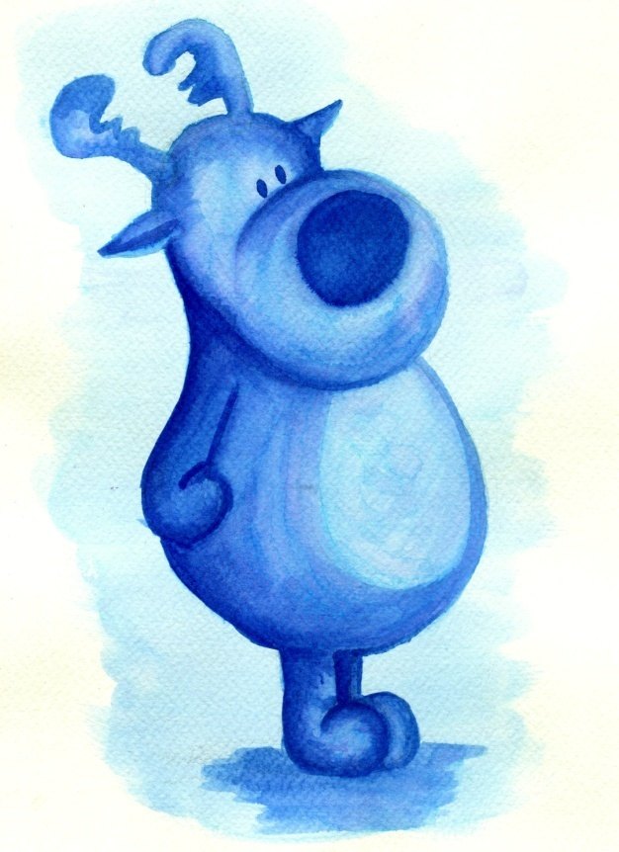
Fig. 14: Blue Portrait
The final approach we took was using black, ink pens. A number of loose sketches were done of Puddin Wuddin and his comrades. We kept the drawing as free and as quick as possible. First we would draw the characters individually and then add the water, (Figure 15). We kept the drawing technique loose and sketchy, remembering what Blake taught us through our analysis.
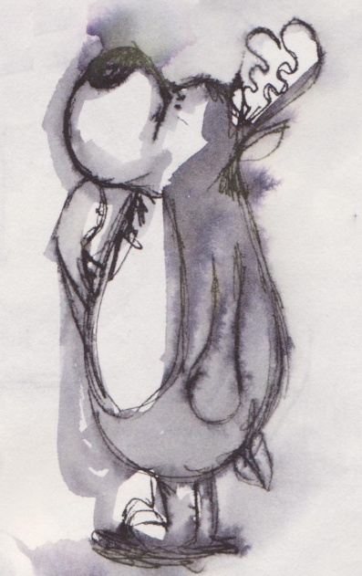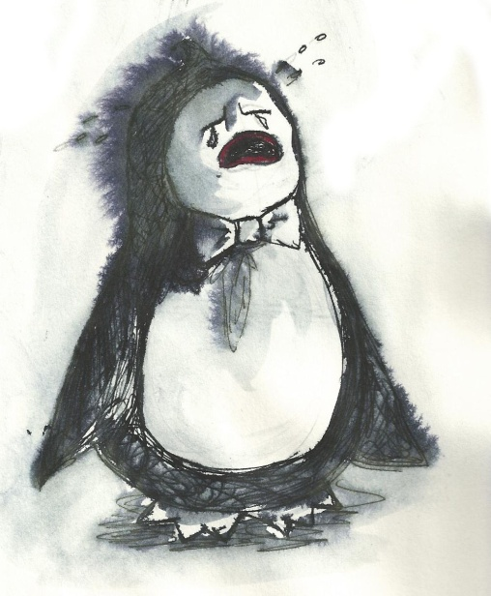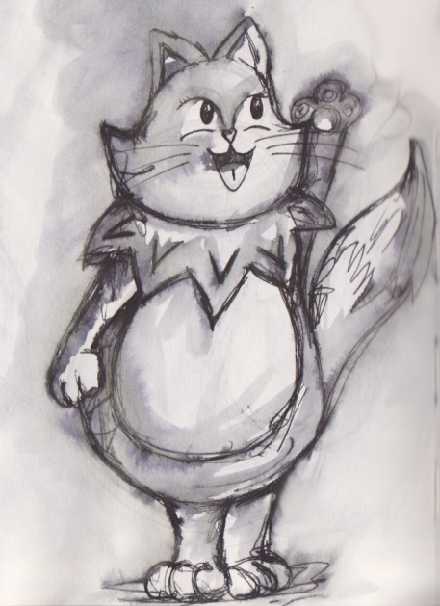
Fig. 15: Our Style

We wet along the outline of the drawing first. This gave them a hazy, grey background. After, we work more with the water, giving the characters shading and shadows to make them look a little more three dimensional. We add more water to the ink where we want shadows and less water in the places we want to say light. This was a style we felt comfortable using. The style suits the story setting. It is winter time. Winter is associated with cold, dark, grey weather. The ink and water create a wintery feel, but it is not too cold or hard. It still looks welcoming. It gave our characters a comforting and snuggly feel just like a child’s toy.
Finding a unique style proved to be a difficult task. It took a lot of experimenting with different materials in order to come up with one that was right for this project. Our characters are soft, cuddly and sweet creatures. We want children to relate to them and love them. We believe that our final style is perfect. It gives a cold, winter like feeling, but it is not as harsh or as bitter as the season. This style gives the characters softness and makes them look like cuddly toys. It’s a style that suits Puddin Wuddin and his story. We believe that young children will be drawn to the warmth and softness this style gives Puddin and his friends (Figure 16).
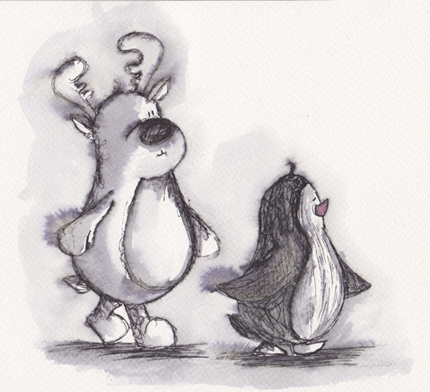
Fig. 16: Final style
5. Story and Story Boarding
Our next ambition was to write a story for our characters. We wanted to write a children’s book that would be entertaining. We wanted something that would hold a young child’s attention from beginning to end and also something that what teach the child a lesson. The moral of our story is very simple: never judge a book by its cover. We are telling children it doesn’t matter what people look like on the outside. It’s the inside that truly counts. It is a simple message, but we feel it is an important one.
We went through some brainstorming techniques in order to write our story. We put pen to paper and began write out all of our ideas. We started with a couple of words, a line or maybe a small cartoon. As the idea began to become clearer, we could elaborate more. We began to give the story more depth and detail. By writing the story out in detail, it helps us get an idea for the different illustrations we could have on certain pages of the book. The plot of the final story begins with Puddin Wuddin playing in the snow when Timothy comes to see him. Timothy tells Puddin about a wood and he thinks they should go and explore it. The pair set off on their adventure. In the woods they meet Titch, the snow cat. They are afraid she is a monster and will eat them. When they take the time to get to know her, they realise she is not a monster at all.
We edited the story to make it easier for children to read. We condensed the story down to what we believe will be enough to keep a young child engrossed in the book. Once we had our story, we began to put the words and the illustrations together to form our book. We did this by drawing out story boards (See figure J). This technique is a very easy way to lay out the whole book. We could see what words and images should go together on the page. It allows us to see what was working and what wasn’t. It gave us a fair idea of the layout of our final piece.

6. Evaluation
Over all this was a very enjoyable and satisfying project. We are delighted to say that we have created our own unique characters and a story to go along with them. Although writing an original story was quite difficult at first, in the end we produced one we are proud of. We are delighted with our final characters. Puddin, Timothy and Titch are all equally cute and loveable. We feel that they are the type of characters that young children will love. They are adorable and huggable. Just like a cuddly toy. We also developed our very own style of illustration. This was a huge achievement. We have found an original style that suits our work and the story we are trying to tell.
To find out whether or not people would like Puddin Wuddin, we set up a Facebook page dedicated to the little reindeer. On this page we have uploaded several illustrations of Puddin and his companions. The feedback has always being very positive. So far, we are delighted to say that Puddin Wuddin has a total of forty three fans, (Puddin Wuddin, 2012). Generally, Puddin is very well received by young people and adults alike. His cute, innocent appearance makes him a loveable character of both young and old.

7. Conclusion and Future Work
Throughout working on this project we have kept a blog dedicated to Puddin Wuddin, (Golden Cheeks, 2012). We started it in January 2012 and we are still working on it. It is like a timeline of Puddin’s creation. It’s hard to believe that Puddin was just a toy reindeer and now he is the star of a children’s story.
In the future we hope to make another adventure for Puddin to go on. We feel that if we develop our style more and perfect it we will be able to design another children’s book. This was a satisfying and creative project. It allowed us to go outside our comfort zone and create something different and unique. We are very proud of the final outcome. We feel we have achieved our goal to write and illustrate a new and original story book for young children.

Acknowledgements
The last three years have gone by so quickly. It is hard to believe that this is one of the last assignments I will be handing into the small office in the Foyle Arts. It is true, time flies when you are having fun!
I would like to thank all the staff and tutors in the University of Ulster, Magee Campus. All your advice and encouragement got me through these past three years. I would like to say a special thank you to my project supervisors, Paddy McLaughlin and Mark Cullen, who guided me through the last stretch of the semester and also helped me produce a project I am proud of. Thank you to Prof. Paul McKevitt who helped me with my final report and who never failed to reply to my many emails seeking his advice. I would also like to thank Clive Bright, Brigit Egging, and Oonna McGrath, for all encouragement and helpful information before I left home to go to college.
To the Design class of 2012. We have had a memorable three years. I wish you all the best in the future. Thank you to my best friends, Lisa Milmoe and Sinead Brehony, for the many nights we spent together fretting and complaining about our course work. We made it in the end. To David Marshall, thank you for your support and always listening to my worries about course work and deadlines. Thank you to Carol Marshall for your helpful tips on how to write a good children’s book.
I would like to say special thanks to my family. If it was not for them I would have never come this far. Thank you to John and Colm, my little brother, who made the weekends less stressful and more fun. A big thank you to my parents, Natalie and Martin, for absolutely everything they have done for me and for all the help and support they have given me these past few years.
And of course, a big thanks to the little reindeer that made this all possible, Puddin Wuddin.

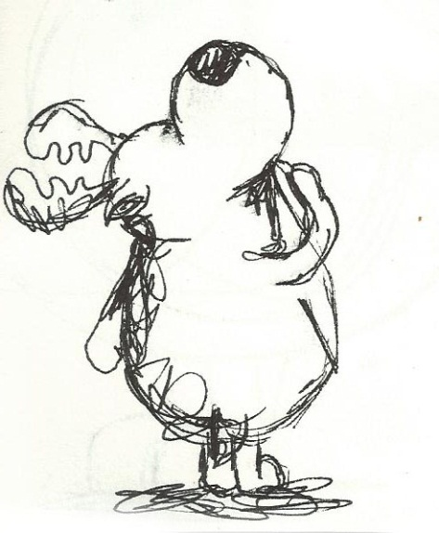
References
Aardman (2012), http://www.aardman.com/. [Accessed 30 April 2012].
Alfie (2012), http://www.alfiebooks.co.uk/index.asp. [Accessed 05 April 2012].
Barbara Firth (2012), http://www.walker.co.uk/contributors/Barbara-Firth-1742.aspx. [Accessed 30 April 2012].
Dahl, R. (1988), Matilda, London, England: Jonathan Cape Limited
Dahl, R. (1980), The Twits, London, England: Jonathan Cape Limited .
Dahl, R. (1975), Danny Champion of the World, London, England: Jonathan Cape Limited.
Francesca Simon, http://www.francescasimon.com/index.asp. [Accessed 30 April 2012].
Frida Kahlo, http://www.fridakahlofans.com/. [Accessed 30 April 2012].
FRIDA KAHLO (2012), http://www.fridakahlo.com/. [Accessed 30 April 2012].
Frida Kahlo (2010), http://www.frida-kahlo-foundation.org/. [Accessed 30 April 2012].
Fuentes, C, (2005), The Diary of Frida Kahlo, New York, U.S.A: Abrams.
Gilad Soffer, http://theillustratorsagency.com/projects/gilad-soffer-watercolour-childrens-illustrator/. [Accessed 30 April 2012].
Golden Cheeks (2012), http://fmpgoldencheeks.tumblr.com/. [Accessed 01 May 2012].
Hahn, D. (1996), (2000). Millenium Edition Disney's Animation Magic, 5th ed. United States of America. : Disney Enterprise inc.
Hughes, S. (1997), Alfie and the Birthday Surprise, The Boldley Head, Great Britain.
Hughes, S. (1997), Alfie Gets In First, Random House Chilfren's Books, London
Kerr, J. (1973), The Tiger Who Came To Tea, London, England: William Collins Sons & Co Ltd.
Lord, P. Silbey, B, (2010), Cracking Animation, London, England: Thames & Hudson.
Lucy Casson (2012), http://www.cabaret.co.uk/artists/lucy-casson/. [Accessed 05 April 2012].
Martin Waddell, http://www.channel4learning.com/sites/bookbox/authors/waddell/. [Accessed 30 April 2012].
Owl Babies, http://www.edspire.co.uk/year_2011/03/23/book-review-owl-babies/. [Accessed 30 April 2012].
Park, N.S., Brian (2009), The Art of Wallace and Gromit, United Kingdom: EGMONT BOOKS.
Patrick Benson (2012), http://literature.britishcouncil.org/patrick-benson. [Accessed 30 April 2012].
Pingu, http://www.hitnewsonline.com/press/detail/pingutrade_creator_bio/pingu. [Accessed 30 April 2012].
Puddin Wuddin (2012), https://www.facebook.com/PuddinWuddin?filter=3 [Accessed on 2 May 2012]
Quentin Blake, (2011), http://childillustration.blogspot.co.uk/2011/01/quentin-blake.html [Accessed 24 April 12].
Quentin Blake, (2012), http://www.westovergallery.co.uk/Artist/Roald-Dahl-and-Quentin-Blake/Danny-The-Champion-Of-The-World.aspx?Page=2&ShowType= [Accessed 24 April 12].
Quentin Blake, (2006), The http://www.show.me.uk/site/news/STO1086.html [Accessed 24 April 12].
Quentin Blake (2012) http://www.quentinblake.com/en/. [Accessed 30 April 2012].
Quentin Blake - Penguin Books (2012), http://www.penguin.co.uk/nf/Author/AuthorPage/0,,1000003582,00.html. [Accessed 24 April 2012].
Roald Dahl - The Official Web Site (2012), http://www.roalddahl.com/. [Accessed 03 April 2012].
Sergiev, G,(2002), How to Catch Fearies, Great Britain: Godsfield.
Shirley Chiang (2012), http://theillustratorsagency.com/projects/shirley-chiang/. [Accessed 30 April 2012].
Shirley Hughes- Penguin Books (2012) http://www.penguin.co.uk/nf/Author/AuthorPage/0,,1000015904,00.html. [Accessed 05 April 2012]
Simon's Cat – Home (2012), http://www.simonscat.com/. [Accessed 30 April 2012].
Simon, F. (1997), Horrid Henry's Nits, London, England: Orion Children's Books.
Tesco (2012), http://www.tesco.com/. [Accessed 01 May 2012].
The Guardian (2012), http://www.guardian.co.uk/books/2008/nov/29/judith-kerr-tiger-came-tea. [Accessed 30 April 2012].
The Illustrators Agency (2012), http://theillustratorsagency.com/. [Accessed 30 April 2012].
The Tim Burton Collective (2012), http://www.timburtoncollective.com/. [Accessed 30 April 2012].
Tofield, S, (2009), Simon's Cat. Great Britain: Canongate Books.
Tony Ross (2012), http://www.penguin.co.uk/nf/Author/AuthorPage/0,,1000014115,00.html. [Accessed 30 April 2012].
Walt Disney Biography (2012), http://fuv.hivolda.no/prosjekt/gunnargrodal/bio.htm. [Accessed 30 April 2012].
Appendix
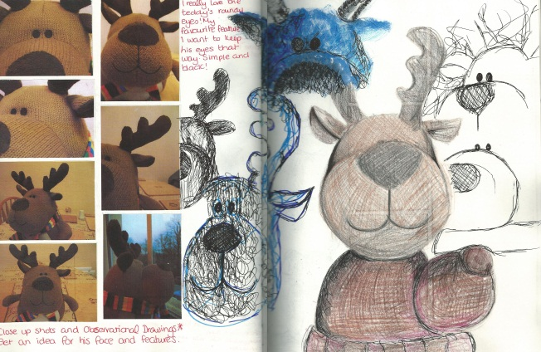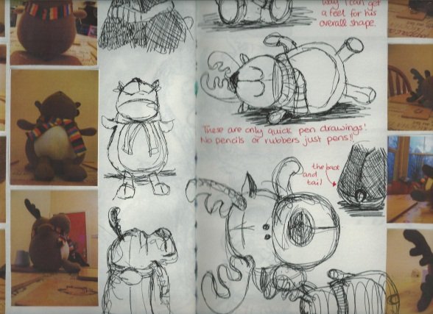
Fig. A: Observational Work- Puddin

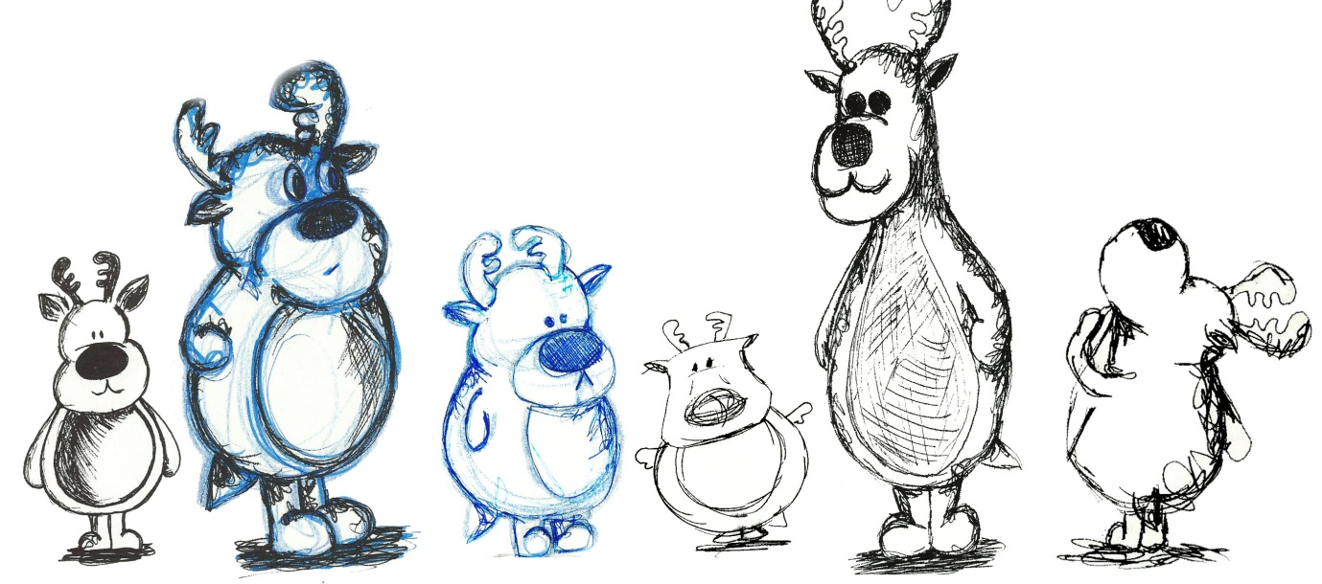
Fig. B: Character Design- Puddin
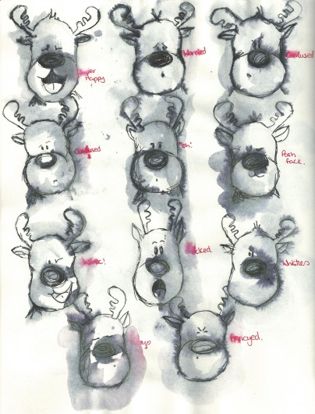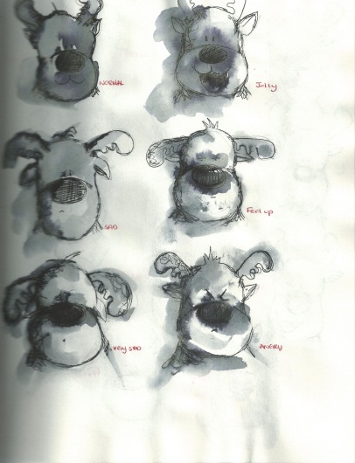
Fig. C: Emotions- Puddin

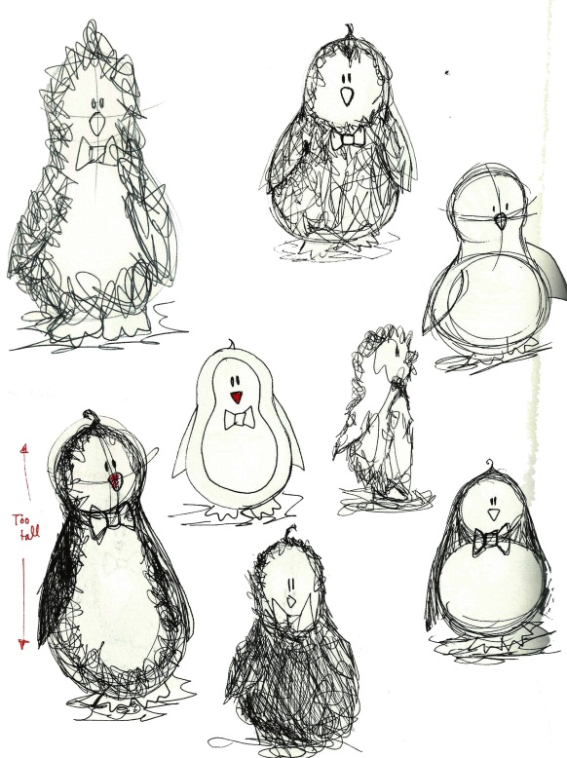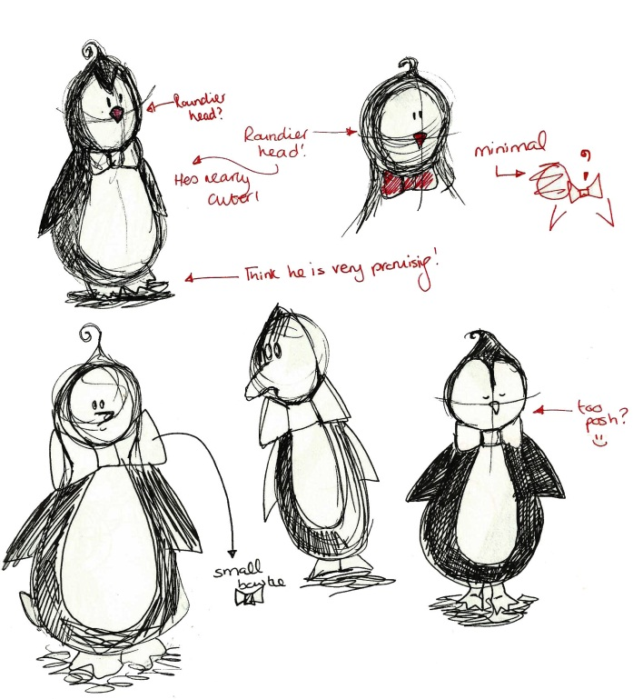
Fig. D: Character Design- Timothy
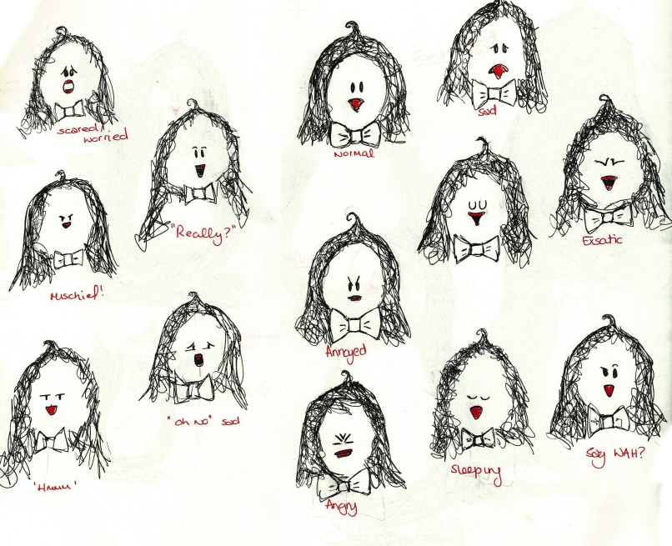
Fig. E: Emotions- Timothy
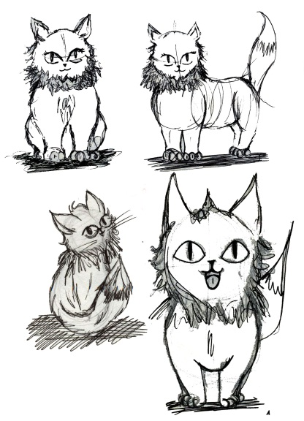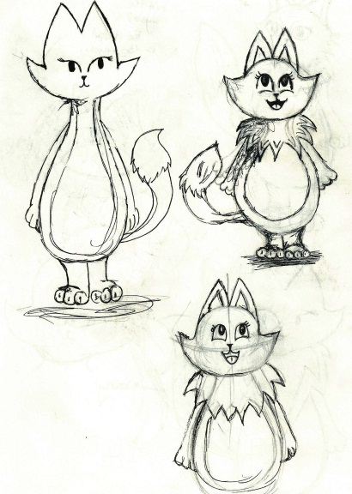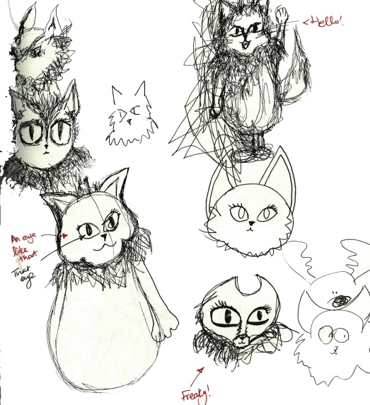
Fig. F: Character Design- Titch
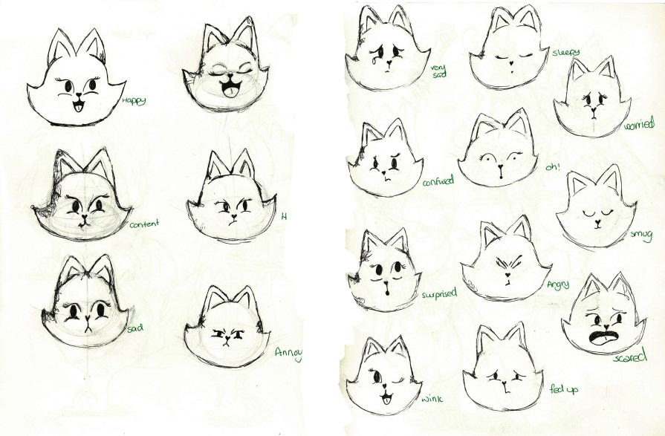
Fig. G: Emotions-Titch

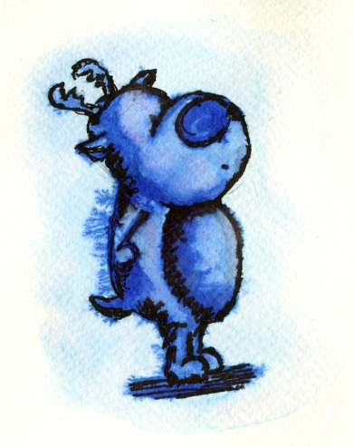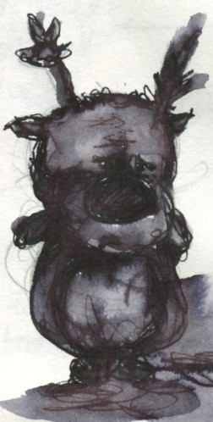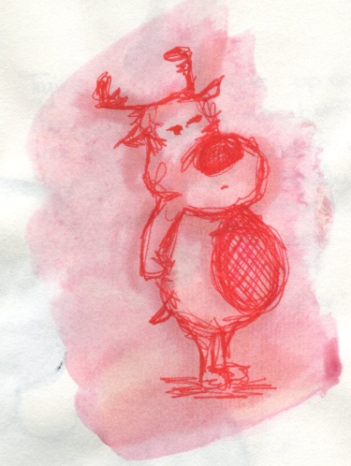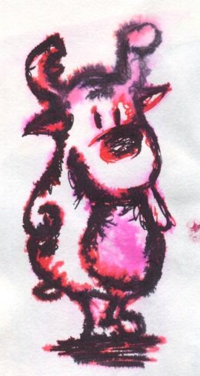
Fig. H: Ink Style

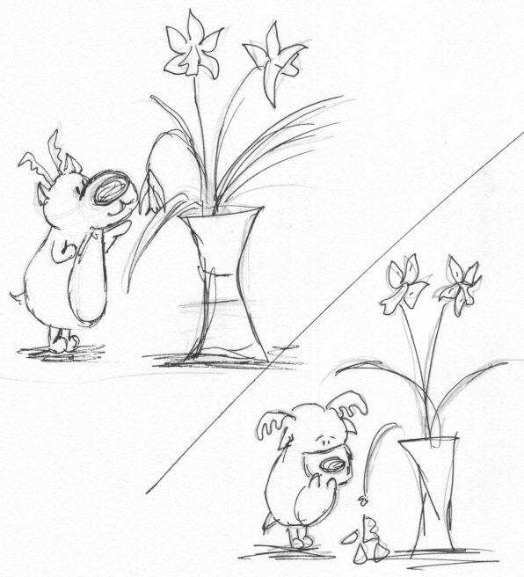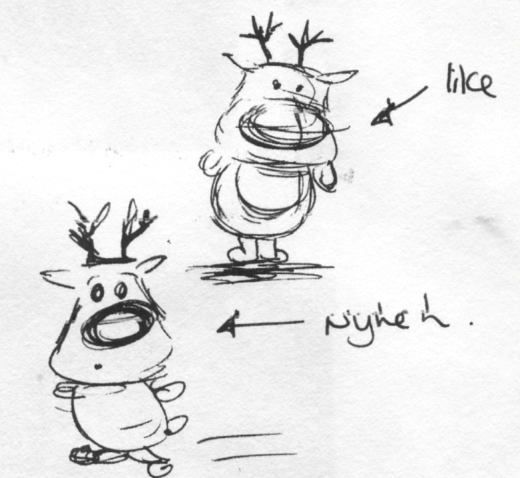
Fig. I: Comic Strip Style

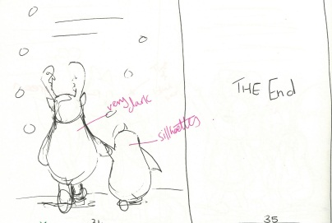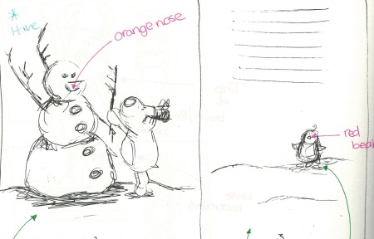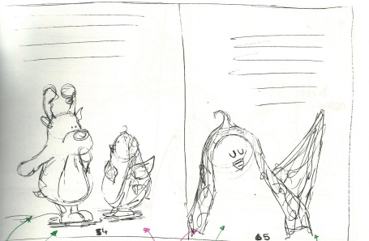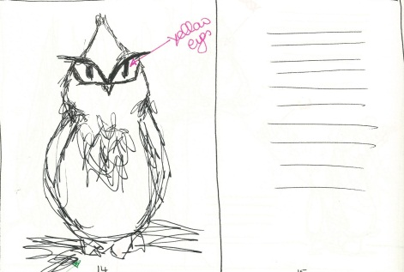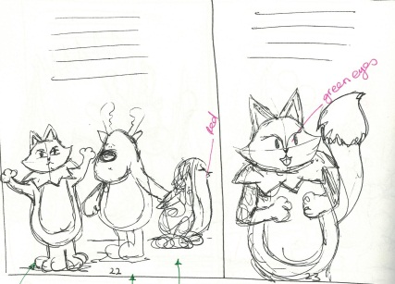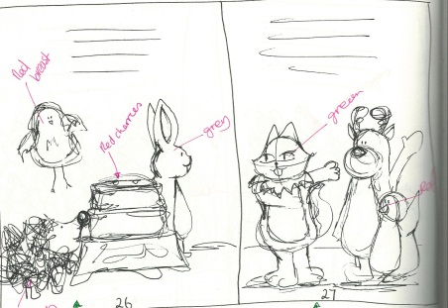
Fig. J: Storyboards

Bed Time Stories: Creating Puddin Wuddin

Natalia Golden
B00539273

Bdes Design and Communications DES 518

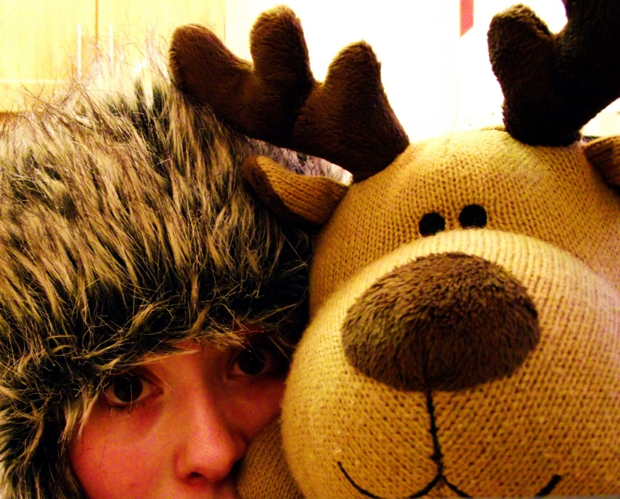

3rd of May 2012

