R-evolution
AN ILLUSTRATED E-BOOK ON THE SUBJECT OF EVOLUTION

Project title - R-Evolution
Student - Donna Quinn
Student ID - B00599238
Course title - M.DES Design for Creative Practice
Module title - Design Implementation (Research paper)
Module code - DES811
Module Coordinator - Prof. Paul Mc Kevitt
School name - School of Creative Arts and Technologies
ABSTRACT
Since the publication of Charles Darwin’s book ‘On the Origin of Species’ in 1859 (Darwin, 1859), the theory of evolution has accumulated supporting evidence to prove itself as the best explanation we have for the existence of all life on earth. All of the information gathered on this subject is already available for people to learn about but the aim of this eBook is to present the subject of evolution in a quirky but simply written format. The objective of this eBook is to present the subject of evolution using a clear concise writing style and simple colour illustrations to target a reading market who are daunted by the books already out there on the subject.
Primary data collected from a survey of one hundred people earlier in the year demonstrated an extremely low level of knowledge and understanding about the Big Bang Theory and the Theory of Evolution. It also provided an encouraging high vote in favour of an eBook such as this to help promote a better understanding of the subject.
This eBook has a specific niche; it is an illustrated body of work that is aimed at young adults and above who want to learn about the subject of evolution in an exciting way. The title of the eBook is ‘R-evolution’ to emphasise its intention to revolutionise peoples’ understanding of this subject area and to question previous beliefs about how we came into existence.

1. INTRODUCTION

This eBook was inspired by many authors, designers, documentaries and website sources during the creation of this eBook, but one quote in particular resonated perfectly with the ambition for quality in the final piece.
“In the beginning I looked around and, not finding the automobile of my dreams, decided to build it myself.” - Ferdinand Porsche (Germany, 1932)

The creation of this eBook began with a single thought. Throughout the sections of this dissertation, evidence of accumulating ideas and their implementation show how the eBook reached its conclusion. The following is a brief overview of what each section will discuss.
Section Two describes the background research of the eBook and specific reading, visual and website material that helped to construct the vision for this project.
Section Three details the methodology of designing this book including the timetable of project planning, a synopsis of the illustration process, the extensive use of design programs Adobe Photoshop and Adobe InDesign and visual proof of the technical design process.
Section Four explains how the methodology process in Section Three was implemented. It makes reference to significant challenges faced along the way and how they were overcome.
Section Five evaluates the masters design project as a whole; including a survey conducted to validate the necessity for this particular style of eBook and a recent feedback questionnaire based on reviews of one of the finished book chapters.
Section Six relates this eBook to other work published on the subject of evolution and discusses the unique selling points of this project. It identifies its niche market using the results of the evaluation section to prove its selling potential.
Section Seven concludes the dissertation, confirming the points outlined in the introduction and describes the future plans for this eBook.

2. BACKGROUND RESEARCH
2.1 – Origin of idea
The idea for this eBook was initially inspired by the famous evolutionary biologist and author, Richard Dawkins. His book ‘The God Delusion’ (Dawkins, 2006) introduced the concept of evolution to the student and clearly explained why it provided a more satisfying reason for human existence. He dedicated his book in memory of the late screen writer and author Douglas Adams, whose quote resonated with Dawkin’s intention for his book and also inspired the aim of this eBook
“Isn’t it enough to see that a garden is beautiful without having to believe that there are fairies at the bottom of it too?” (Adams, 2003, p. 9)
This eBook intended to explore the beauty of evolution without any complicating language or waffle. It would be nicely decorated with descriptive illustrations to help readers through some of the more difficult explanations. But first, the research had to be gathered and studied.

2.2 – Research for writing about the Big Bang Theory and the origin of life on earth
Most of the information the author needed to write a chapter on the Big Bang Theory came from the bestselling book ‘A brief history of time’ (Hawking, 1996) by the famous mathematician Stephen Hawking. In this book, his intention is to explain the wonders of the universe in the least complicated way possible. It was extraordinarily thorough but tedious at times to extract the basic information needed to write the eBook chapter.
Another helpful reference to clarify some of Hawking’s more complicated explanations was a website called cosmolearning.com (2012). It broke up the stages of the expansion of the universe and explained how matter combined to form stars and planets.
Richard Dawkin’s bestselling book ‘The Selfish Gene’ (Dawkins, 1976) explained how the chemical conditions of a young planet earth provided the perfect setting for the first living single cell organisms to evolve and how they might have done so. It also explained how the process of evolution can produce highly improbable complex forms of life through a gradual accumulation of mutations over millions of years.

2.3 – Research for writing about the evolution of humans
A website called onelife.com (2011) summarised the evolution of creatures that lead to humans. It provided a lot of detail on each species that evolved specifically within the hominid clade to which we belong.
A book called ‘Bones, stones and molecules’ (Cameron and Groves, 2004) written by David W. Cameron and Colin P. Groves provided the evidence of this evolution by showing fossilised bones of these creatures and the tools they left behind. It gives an interesting insight into how they lived and why they evolved.
Steven Pinker’s book, “How the mind works” (Pinker, 1997) and an interview he conducted for a television series called ‘Evolution of the Mind’ (2012) provided detailed information on internal evolution, specifically the rewiring of the human brain to support intelligence, consciousness and speech. Another book of his, ‘The better angels of our nature; why violence has declined in then human species’ (Pinker, 2011) explores the cultural and behavioural evolution of humans.

2.4 – Research for writing about the future of human evolution
Alvin Toffler, who wrote the best-selling 1970’s book ‘Future shock’ (Toffler, 1970); predicted the dangers of accelerating change in technology and cultural behaviours. His research confirms the gap between the evolutionary time that it takes to evolve a brain to cope with new situations and the rapid evolution of technology and cultural etiquette that has long since bypassed our own.
Two documentaries watched as research for this eBook provided an interesting insight into two hypotheses that deal with a future with and without humans in it. One was called ‘Population Zero’ (2005) which explored the aftermath if humans were to suddenly vanish into thin air indefinitely. It showed the control humans have on this planet and all other life that lives on it and how that grip would gradually loosen over time. The other documentary was called ‘Can we live forever’ (2011) which explores the possibilities of human immortality and how science has identified exactly what needs to be done to achieve it.
These books, websites and documentaries, along with others listed in Appendix A, provided the project with most of the information needed to research certain topics more intricately. Educational websites were researched regularly to reiterate some of the more complex explanations in the books and to quickly access updated information on specific topics.

2.5 – Visual Research

As part of the plan to illustrate this eBook, a lot of visual research had to be undertaken. Some of the researched books, documentaries and websites provided useful diagrams which were collected and made into mood boards. A sample of these mood boards can be seen in Appendix B. All of this visual research helped to clarify some ideas that were difficult to understand through words alone.
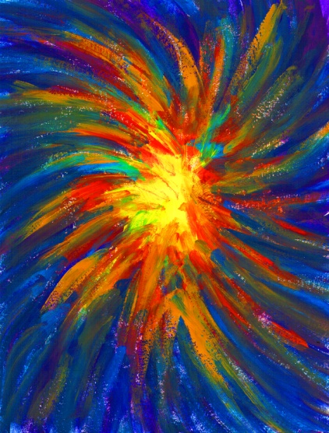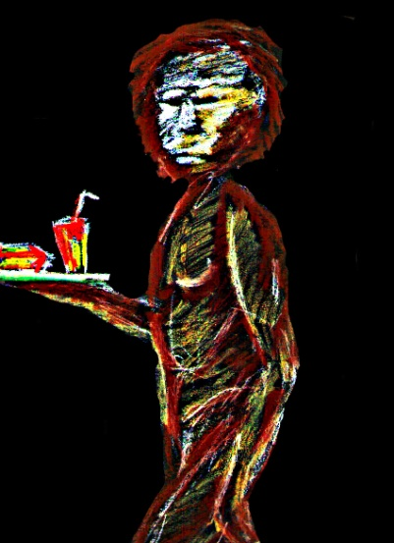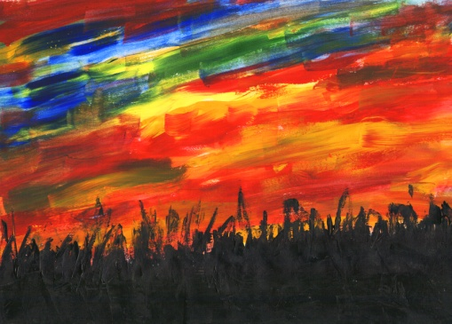

3- METHODOLOGY
3.1 - Overview
The methodology for creating this eBook was as follows: an extensive sole research period, first draft written, sketch work development, finalised written draft and illustrations completed, and compilation and formatting of the two aspects of the book. Throughout this methodology, continued research was necessary to keep updated on new breakthroughs.

3.2 – Development of writing style
As the bulk of research was gathered, the author began writing a rough draft of each chapter based on all new information learned. The method of this particular task was quite straightforward; take a section of information, simplify it and write it in a clear and interesting style. This method was applied to every chapter of the book and when the first draft was completed, the process began again.
Whilst the book redrafting continued, the fourth draft was imported into InDesign into a pre-decided textbox layout as a template for the book. Any further changes to the written aspect would be made within this design program.

3.3 – Development of drawing style
As the first draft started to take shape, more attention was given to developing a definite style of drawing for the book. Prior to any major sketching being undertaken, the author/illustrator intended the book to be a highly colourful piece. But as the drawing time increased, opinions changed. A more subtle illustrative style using a 0.7mm black gel ink pen did most of the work, with a hint of colour woven throughout the book.
By June, most of the final illustrations to be inserted into the book were drawn. Each design page contained approximately four to eight illustrations so the first step was to scan the page into Photoshop. When the page appeared on the screen, it was brightened, contrasted and removed of any blemishes. Then each illustration was cropped and named. Each image was placed into a folder according to which chapter it belonged in. The illustration would then be manually placed one by one into the InDesign document where it would be subject to readjustment, resizing and formatting alongside the text.
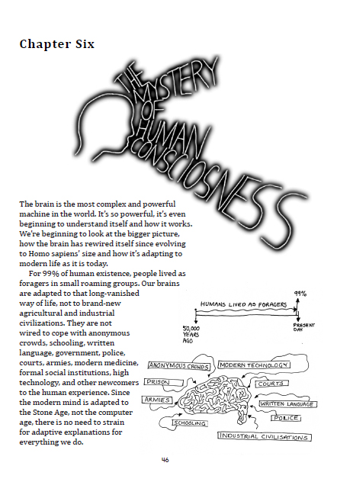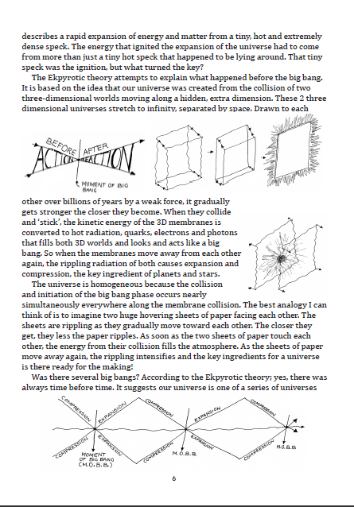

3.4 – Setting up an InDesign document for importing text and illustrations
In June 2012, the InDesign document for the book was being setup ready to receive the text and imagery completed. Prior to this, a lot of book and internet research was undertaken to learn about designing type for eBooks as well as an in-depth tuition on how to create a good typography layout in Adobe InDesign. A list of typography books read in preparation for this stage is given in Appendix A. One book in particular was used on a daily basis called ‘InDesign Type’ (French, 2006). It clearly explained the steps to setting up an InDesign document for a book as well as guidelines for creating paragraph styles, page numbers, tracking, kerning and leading setting to maximize the legibility of the text.
The final stage of this project’s methodology was to continue improving the appearance and styling of the illustration and typography layout as well as continually rewriting some areas of the book before the final hand-in.

4 – IMPLEMENTATION
4.1 – The physical book versus the eBook
One of the initial decisions to be made was deciding whether to create a physical book or an eBook. Initially the sway was toward the physical book because it seemed at the time to be more straightforward. The opinion changed soon afterwards for two main reasons. Firstly, after researching more deeply into the benefits of creating an eBook, the straightforward uploading process of an eBook to an online global platform and Amazon’s generous 70:30 royalty division in the author’s favour helped to make this decision. The second reason was established after receiving a reply from a publishing company in Northern Ireland regarding costs of printing a physical book. An email was sent enquiring the rough cost of printing for a 150 paged, A5 sized full colour book. The publishers replied quoting that a beginner’s batch of five hundred hardback books would cost approximately £10,000. That email briskly diverted all attention to creating an eBook!
4.2 – The consequences of choosing to design an eBook
But by choosing to design an illustrated eBook, a few more challenges were faced. EBooks with no illustrations, that is to say, straight text, are mostly uploaded online in epub formats or similar which auto syncs the text to fit the screen it’s being read on. The most used screen sizes that eBooks are read on are the 7” Kindle, Nook or Kobo tablets, the 10” iPad, the 3.5” iPhone and iPod touch. Although tools exist that make it relatively quick and easy for a designer to see the page on the right screen size and move things around a bit, that doesn’t really solve the problem. An illustrated book publisher would really have to design and layout each book at least twice (for the 10-inch and 7-inch screens) and possibly three times to fit the iPhone screen too. That would mean designing three different files, so it’s impossible to move the illustrated eBook across devices and have them auto-sync the way Kindle, Nook, Kobo, and Apple enable for straight text. This means, for illustrated eBooks, one size definitely does not fit all. For now, the eBook would be targeted at the kindle market and depending on its success; decisions could be made at a later stage regarding the design for other screen sizes.

4.3 – Developing a definitive drawing style

One of the most important aspects of this eBook’s design was creating the right style of illustration to suit the context of the words. A lot of experimentation with colour and drawing styles was undertaken. Extensive examples of these experiments are given in Appendix B. Initially the drawing style for the eBook was to be a very clean cut Adobe Illustrator style as it looked professional. This plan changed for several reasons. Firstly, this clean cut style was not one that came naturally to the designer. The style that produced the most natural and satisfying results was a personal one. The debate about using it in the eBook was concerns that it looked too infantile.
After several meetings with the design development supervisor, the agreed opinion was that the finished eBook would benefit from a unique style and it lightened the heavy subject of evolution considerably. After several weeks of sketching illustrations, confidence in this style increased; they could be produced at the rapid rate the time plan demanded. The volume of information that the reader was taking in didn’t need any major distractions with heavy colour imagery. Simple inked illustrations with a light addition of colour complimented the overall context much more successfully.
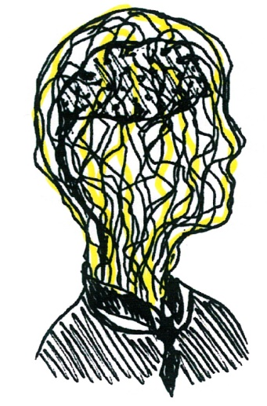

4.4 – Editing the eBook

Being the sole designer, writer, illustrator, editor, compiler, publisher and advertiser of a book means making a lot of choices on how to improve the piece. Some choices are much more difficult than others. For example, one chapter of the book had to be cut completely to benefit the overall theme. Many hours had been spent over many weeks researching, writing and sketching for this topic but it no longer fit in with the rest of the book. It described the conflicts between science and religion. It was a subject that the author had many opinions on and found difficult from keeping out of the writing. It was realised that it may appear derogatory to those with spiritual/religious beliefs who might be reading it. From the beginning, this book was to be designed to display the facts of evolution in an interesting way, never to be demeaning or condescending to those with a belief in a higher power. It is a personal opinion that people can decide for themselves if they want to accept the facts or not. The excommunicated religious chapter is given in Appendix C.

4.5 - Deciding a price for the eBook
To help decide what price would be charged for the eBook, investigations were made into Amazon’s top 100 non-illustrated and illustrated books. For the non illustrated top 100, there were only fifteen percent of books priced above £5 and fifty-one percent priced below £2.50. For the illustrated top 100, there were sixteen percent priced above £5 and a massive sixty-five percent priced below £2.50. It was a surprise to learn that illustrated books were kept at such a low price, lower in general than non illustrated books just to stay in competition for the most sales. Research began on the psychology of book pricing so as to set the eBook at the optimum price and get the most out of it. It is certain that the eBook will be under £5, how far under that price yet, is still uncertain.
5 – EVALUATION
5.1 – Survey conducted in January to determine the market value of this eBook

As part of research to validate the market value of the eBook, a survey of one hundred people was conducted about the subject of evolution. One of the questions asked if people preferred illustrated books to plain ones. Sixty-nine percent said yes. In the comments box below this question, people commented that it breaks up the text nicely, it makes the book flow better, and for informative books especially, illustrations are very important.
Another question asked if people thought that an illustrated eBook on the subject of evolution could promote a better understanding of it. Ninety-two percent of people said yes. Some said ‘it would be the first thing to draw my attention to it’. One person said that they think many people disagree with evolution because they don’t understand it and that an illustrated book could help clarify a few things for them. This confirmed that this eBook had plenty of financial potential and had a niche on the online eBook market. The January questionnaire results are given in Appendix D.

5.2 – Questionnaire in August to review eBook before publication

As the eBook approached completion, a survey of twenty people was carried out to review chapter one. It was handed out to several professionals from marketing, design, journalistic and other backgrounds. They were asked to read it in full and fill out a questionnaire to evaluate its marketing potential and general opinion. The results were very positive.
Question four asked if people thought the accompanying illustrations helped to explain the story of the Big Bang Theory. 90 percent said yes and ten percent said maybe. One respondent replied;
“Yes. The chapter was much easier to read because of the illustrations. They had a nice light, simplistic style”.
Question six asked if they would be interested in reading the rest of the book based on reading the first chapter. One hundred percent said yes. One respondent added;
“This chapter alone has helped me understand a lot of things I previously didn’t have a clue about. I’d love to learn more about evolution as well”.
Question seven asked if they thought this book, based on the first chapter appeals to people that know little or nothing about the Big Bang Theory or The Theory of Evolution and want to learn about it in a clear and interesting way. 100 percent said yes. One person said;
“I have always been interested in learning about the subject but never thought I would be able to understand it. It seemed too complicated but this book makes it so easy to read about”
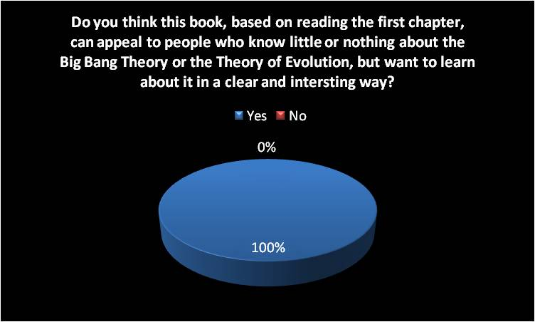
Question eight asked people to add any other comments they had based on their reading of the first chapter. The following are a few of those comments.

“This chapter is anything but daunting, it’s exciting to read and easy to understand. I’d defiantly buy this book to read the rest of it.”

“This book targets a new readership market. It’s a beginner’s book for adults that may know nothing about the Big Bang Theory or the Theory of Evolution but want to learn about it in an exciting way”.

“Although I had previously understood a lot of the information described in the sample first chapter, I much preferred this style of writing. I wish I had read something like this before reading other complicated books on the subject”

“I was drawn in by the book title and cover illustration immediately. It’s so clever and interesting to look at, and the sample chapter didn’t let it down, very enjoyable and informative”.

“Very impressed with the first chapter and love the illustrations, so original!”

These reviews echo the original aims and objectives for this eBook. It confirms that this is indeed a unique body of work, it has a lot of marketing potential and it targets the niche market it was intended for. The entire review questionnaire results are given in Appendix E.

6 – RELATION TO OTHER WORK
This eBook is for people who want to learn about the subject of evolution and the human psyche in an exciting way. With the greatest respect to famous authors like Richard Dawkins, Steven Pinker and Daniel C. Dennett; their books contained the knowledge needed, but they weren’t personally invigorating to read. They were text heavy, long-winded and sometimes lacked any real connection with the reader. Their books tell the story, but not with the passion that this eBook tells it with.
The aim of this eBook is not only explain how the earth and life as we know it came to be but to look deeper into the wonderful species that is the human being. It talks about the complex computer that is our brain; how did we learn language? What are emotions? What proof is there of evolution in our own bodies that we can see for ourselves? It explores future possibilities and asks some of the more philosophical questions; what is the purpose of life? What happens when we die? Is there an afterlife? Can science someday make us immortal?
This eBook is new twist on an old tale. Most of the books researched and mentioned in section one concentrated on one particular topic, and very intensively so. This work was an appetizer to every subject matter which helped to keep it light and fresh. Scientific equations, complicated mathematics and long winded explanations were completely eliminated to avoid putting off the reader.

6.1 – The contrast of target markets between this eBook and other books on the subject

There is a huge market opportunity for this eBook that targets young adults and above. It’s unique in the sense that it contains only the relevant and easy to understand information on the Big Bang Theory, the creation of life on earth, the evolution of life and the human species. It is nicely illustrated to help readers through some of the more difficult explanations and it’s the only illustrated eBook on this subject that is targeted at adults. From the extensive research done to find the competition, it was found that the best and only illustrated books on evolution were targeted at children. Who says that as adults, we’re beyond looking at picture books to help us understand the context of words? A list of illustrated children’s books on the subject of evolution is given in Appendix F.
This eBook holds the type of information that feeds ones of mankind’s most basic traits, curiosity. We have an insatiable appetite to explore and question the world around us. It is the reason why we’ve become the most successful species on earth. It is a sacred gift in a sense. That's why Einstein called it "holy" when he wrote;
"The important thing is not to stop questioning. Curiosity has its own reason for existing. One cannot help but be in awe when he contemplates the mysteries of eternity, of life, of the marvellous structure of reality. It is enough if one tries merely to comprehend a little of this mystery every day. Never lose a holy curiosity." (U.S.A, 1945)

7 – CONCLUSION AND FUTURE WORK
7.1 - Conclusion
This dissertation has discussed and proven what the aims and objectives of this eBook were. This eBook has several unique selling points. It has a specific niche; it is very marketable and has an edge on the books already out there on the subject.
A personal aim for this eBook is to hope that those who take the time to read this information for the first time and who have a strong faith in a higher power, keep an open mind about what has been taught and what is truth. The most dangerous thing humans can do is to close themselves off to the beauty of knowledge and learning. If that had happened through the history of time, we’d still believe the world was flat and that the sun revolved around earth. Our instinct of curiosity has been our greatest asset throughout our evolution, so why stop now?

7.2 – Future work
With the eBook complete, an advertising campaign will begin. The author is keen to plan this properly to give the eBook a chance to accumulate a decent number of sales. Besides word of mouth, this eBook will be advertised regularly on FaceBook and Twitter accounts to gain as much exposure as possible. Amazon offers global advertising packages to suit every budget as well as multiple other websites that specialise in advertising eBooks across the web. Local newspapers will be informed of the eBook’s release as well as the choice placing of some promotional posters to build anticipation.
If this eBook does well, the author would like to design and publish a comic based on it, with much less text and more visuals to explain the story. It could target a more specific market that want to learn about evolution in a more comical way.

8 – ACKNOWLEDGEMENTS
The author/illustrator would like to thank her dissertation and design supervisors for all their help and advice throughout the year. She would also like to thank her family and friends for proof reading her work and giving her some excellent advice and support.

9 – REFERENCES
Adams, D (2003) The Salmon of Doubt. 2nd ed. London. Pan Press

Cameron, D., Grooves. C (eds). (2004). Bones, stones and molecules, Out of Africa and human origins). USA: Elsevier academic press.

cosmology [online]. (2011). Available from: &ltwww.cosmology.org/infor.com>. [Accessed 14th November 2011].

cosmolearning [online]. (2011). Available from: &ltwww.cosmolearning.com>. [Accessed 22nd September 2011].

Darwin, C (1859) On the Origin of Species by Means of Natural Selection. London. John Murray publishing.

Dawkins, R (1976). The Selfish Gene. 1st. ed. Oxford: Oxford university press.

Dawkins, R (2006). The God Delusion. 2nd. ed. Suffolk, Great Britain: Bantam press.

French,N (2006). InDesign type CS2. 1st. ed. Canada: peach pit publications.

Hawking, S (1996). A brief History of Time. 2nd. ed. New York: Bantam books.

Onelife [online]. (2011). Available from: &ltclassroomdexter.orghttp://www.onelife.com/evolve/manev.html>. [Accessed 2nd October 2011].

Pinker, S (1997). How the mind works. 1st. ed. London: The penguin press.

Pinker, S (2011). The better angels of our nature: why violence has declined. 1st. ed. London: The penguin press.

Population zero. (2008). Documentary. Directed by Luloff, C. Canada: Cream productions.

Porsche, F (1932). Newspaper interview. The automobile of dreams. Grafinger Zuiting newspaper.4th April

Through the worm hole- Can we life forever?. (2011). Documentary. Directed by Blake, C. USA: Revelations entertainment.

Toffler, A (1970). Future Shock. 1st. ed. New York: Bantam Books.

APPENDICES

APPENDIX A: My book research
October 26, 2011 at 1:53 pm (Book research) · Edit
I’ll upload all my comments on what I’ve learned from each one when I’ve finished them and scans of pages with useful information.
1)
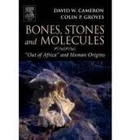
To be perfectly honest, only the first forty pages of this book were of any interest to me; perhaps because it summarised in reasonably clear language what the book would explore. The scans I’ve uploaded below are mostly clear cut diagrams of the path of evolution to Homo sapiens which I’d like to illustrate in my own way for my book…
2)
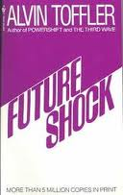
I’ve uploaded a pdf of the notes for this book as they are 16 pages long. My personal opinion of this book is a good one. My only qualm would be that I’d like to read a book like this but with more relevance to the present day. Alvin Toffler wrote this several decades ago and while he has very modern views…alot of the book is very dated in terms of what science and sociology have come up with since its publication.
3)
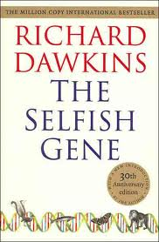
The first forty pages of this book were of most use to me. I learned more about how evolution began back when the earth was a swirling mass of gases and liquid chemicals…the ‘primeval soup’ of life so to speak! Learning about replicator molecules and lethal genes etc. has helped me understand the tree of life on a more microscopic level.
4)
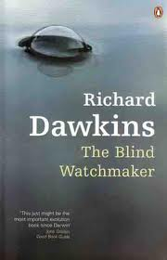
Sorry Richard Dawkins, but you could have put an insomniac to sleep with that book! I don’t even have notes to paste up for this one. I read it, it was boring…complete opposite of what I want for my book…so maybe it was worth reading for that reason alone.
5)
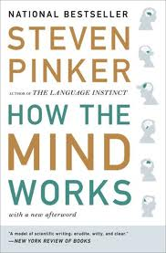
This book was pretty good, perhaps a bit long winded but Pinker has a nice style of writing so he just about held my interest through most of it. Below are the notes from it I found useful.
6)
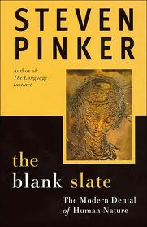
This, unfortunately, was a painful one to get through…not really anything of great use to be…more theoretical than what I’m aiming for. No notes, nothing of real use to me…sorry Pinker!
7)
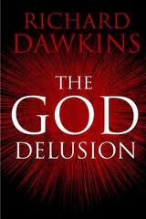
This was an enjoyable read. Although not the angle I’m going for in my quest to explain the facts of evolution; derogation of religions and the beliefs of people, it opened my eyes to the power religion has over so many people. I’m not condemning faith, I’m just hoping to open people’s eyes to some logic and exciting science.
8)
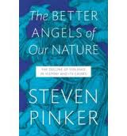
This was a very enjoyable read. This book confirms, through careful studies, that as a whole; the human race has become less violent and cruel over time. Although we have instinctual urges for violence and cruelty, it’s our acceptance of discipline and morality that we generally cooperate well with each other. I will be devoting a good chunk of one of my chapters to this subject, it’s fascinating!
9)
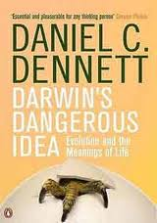
I’ve started reading this bad book, over 500 pages long! why so long, but it looks so damn interesting!
10)
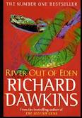
This book didn’t hold much interest for me. It had no particular theme in my opinion and I skimmed through most of it, not intending to waste hours of my time on a book that I wouldn’t take any notes from.
11)
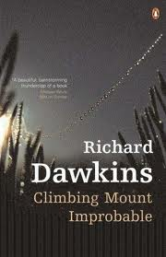
Like ‘River out of Eden’, a boring read. Only read the first third before skimming through the rest and giving up. No notes taken from it.
12)
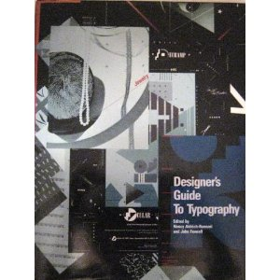
Very good book. I learned alot about typography and interesting layouts
13)
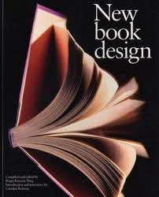
It was the introduction to this book that I liked most, so that’s all I scanned into the pdf below
14)
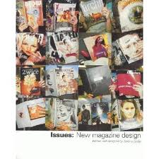
Excellent book. I think I can learn alot from some of the exciting approaches typographers have used in magazine design and apply it to my book to keep it fresh and innovative
15)
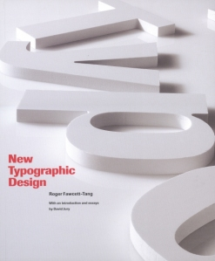
Typography is a science and an art, this book is proof of that!
16)
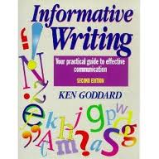
This was a brilliant guide on how to write effectively and to not waffle your words. I’ve learned a great deal about typography layout, what words and phrases to avoid and general tips on the composition of my work.
17)
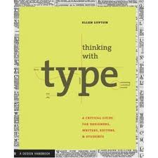
Excellent book, full for great tips for how to layout text nicely
18)
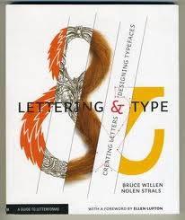
Like ‘thinking with type’, this book has been a great help to me.
19)
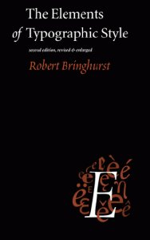
Robin, my design style mentor, lent me this one. It is my new bible! Full of excellent guidelines on how to layout a book in a clever way. Thumbs up!
20)
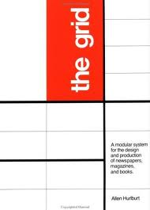
Fantastic book, helping me to decide on the grid that will work best for me.
21)
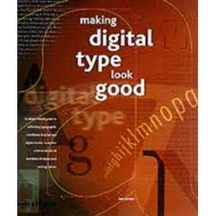
This is the book that’s going to help me conquer the fears on online digital publishing! Full of great advice and quick tips.
22)
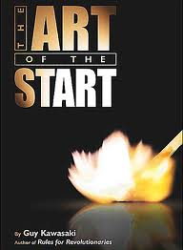
I’ll upload the notes on the following books as I read them
23)
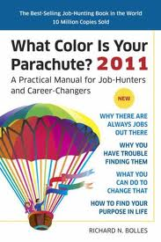
It was a good book..but not really suited to me at all. I prefer the madness and creativity in ‘Rework’ and ‘Linchpin’, so no notes to upload on this one
24)
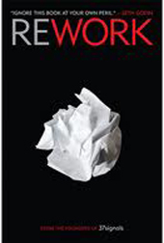
Incredible, fantastic, unputdownable!!! Love this book and everything that it represents.
25)
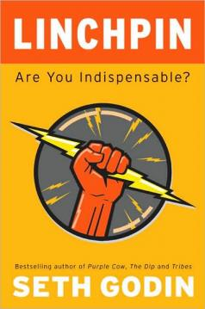
Like ‘Rework’, this book has become my new bible. So well written and every page is bursting with fresh new advice.
26)
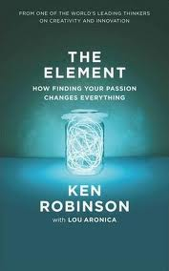
27)
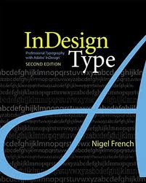
28)
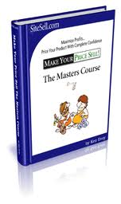
Great book I’m going to read on how to set the right price for my eBook to sell online. I didn’t realise the amount of psychology behind the pricing of a book but there’s plenty to learn. Here’s the free eBook if anyone wants it!
29)
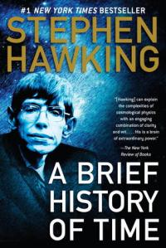

Entire reference list
Ask [online]. (2012). Available from: &lthttp://uk.ask.com/question/why-cant-we-just-stay-awake-all-the-time>. [Accessed 3rd March 2012].

bbc [online]. (2012). Available from: &lthttp://www.bbc.co.uk/science/humanbody/sleep/article>. [Accessed 19th May 2012].

Cameron, D., Grooves. C (eds). (2004). Bones, stones and molecules, Out of Africa and human origins). USA: Elsevier academic press.

chacha [online]. (2012). Available from: &lthttp//www.chacha.com>. [Accessed 11th November 2011].

cosmology [online]. (2012). Available from: &ltwww.cosmology.org/infor.com>. [Accessed 14th November 2011].

cosmolearning [online]. (2012). Available from: &ltwww.cosmolearning.com>. [Accessed 22nd September 2011].

Dawkins, R (1976). The selfish gene. 1st. ed. Oxford: Oxford university press.

Dawkins, R (2006). The God Delusion. 1st. ed. Suffolk, Great Britain: Bantam press.

Dawkins, R (1996). Climbing mountain improbable. 1st. ed. New York: Nortan company INC.

Dailygalaxy [online]. (2012). Available from: &lthttp://www.dailygalaxy.com/my_weblog/2008/03/
does-the-human.html>. [Accessed 17th april 2012].

Dennett, D (1995). Darwin s dangerous idea: Evolution and the meanings of life. 1st. ed. Great Britain: The penguin press.

Einstein, A (1945) Holy curiosity quote

Evolution.Berkeley [online]. (2012). Available from: &lthttp//www.evolution.berkeley.edu>.
[Accessed 22nd October 2011].

Evolution- Great transformations. (2002). Documentary. Directed by Olicker, J., Schmidt, C. USA: PBS.

Evolution- The evolutionary arms race. (2002). Documentary. Directed by Willumsen, G. USA: PBS.

evidencebeyondgenes.com [online]. (2012). Available from: &ltevidencebeyondgenes.com>. [Accessed 9th October 2011].

Examiner [online]. (2012). Available from: &lthttp://www.examiner.com/article/the-21-grams-theory>. [Accessed 14th December 2011].

French,N (2006). In design type cs2. 1st. ed. Canada: peach pit publications.

Hawking, S (1996). A brief history of time. 1st. ed. New York: Bantam books.

How does your memory work. (2008). Documentary. Directed by Gillings, A. United Kingdom: BBC horizon.

Humans4 [online]. (2012). Available from: &lthttp://humans4.beyondgenes.com/>. [Accessed 12th April 2012].

Humansfuture [online]. (2012). Available from: &lthttp://www.humansfuture.org/genetic_engineering.php.htm>. [Accessed 11th November 2011].

Itsnotmagicitsscience [online]. (2012). Available from: &ltwww.itsnotmagicitsscience.com/Howthings work//.>. [Accessed 19th December 2011].

Live strong [online]. (2012). Available from: &lthttp://www.livestrong.com/article/444068>. [Accessed 29th October 2011].

msnbc [online]. (2012). Available from: &lthttp://www.msnbc.msn.com/id/3076707/ns/technology_and_science->. [Accessed 22nd march 2012].

National geographic [online]. (2012). Available from: &lthttp://news.nationalgeographic.com/news/2009/11/091124-origin-of-species-150-darwin-human-evolution.html>. [Accessed 9th September 2011]

Neanderthal- planet of the ape men. (2011). Documentary.Directed by Stewart, D. UK: BBC
Near-death [online]. (2012). Available from: &lthttp://www.near-death.com/experiences/articles010>. [Accessed 18th January 2012].

Onelife [online]. (2011). Available from: &ltclassroomdexter.orghttp://www.onelife.com/evolve/manev.html>. [Accessed 2nd October 2011].

Ornl [online]. (2012). Available from: &lthttp://www.ornl.gov/sci/techresources/Human_Genome/project/about.shtml>. [Accessed 13th May 2012].

PBS [online]. (2012). Available from: &lthttp://www.pbs.org/wgbh/nova/body/what-are-dreams>. [Accessed 7th June 2012].

pbs [online]. (2012). Available from: &lthttp://www.pbs.org/wgbh/evolution/library/07/2/text_pop/l_072_03.html>. [Accessed 4th January 2012].

Pinker, S (1997). How the mind works. 1st. ed. London: The penguin press.

Pinker, S (2011). The better angels of our nature: why violence has declined. 1st. ed. London: The penguin press.

pinker [online]. (2012). Available from: &lthttp://pinker.wjh.harvard.edu>. [Accessed 16th March 2012].

Population zero. (2008). Documentary. Directed by Luloff, C. Canada: Cream productions.

Science-how stuff works [online]. (2012). Available from: &ltwww.science.howstuffworks.com>. [Accessed 29th September 2011].

Sciencehatforum [online]. (2012). Available from: &lthttp://www.sciencechatforum.com/>. [Accessed 11th October 2011].

scientificpsychic [online]. (2012). Available from: &lthttp://www.scientificpsychic.com/workbook/chapter2.html>. [Accessed 3rd may 2012].

Secret life of your body clock. (2009). Documentary. Directed by Sussman, A. United kingdom: BBC horizon.

The secret world of pain. (2011). Documentary. Directed by Learoyd, S. United Kingdom: BBC horizon.

The Brain; A secret History. (2011). Documentary. Directed by Sussman, A. United kingdom: BBC 4 productions.

Through the worm hole- Can we life forever?. (2011). Documentary. Directed by Blake, C. USA: Revelations entertainment.

Toffler, A (1970). Future Shock. 1st. ed. New York: Bantam Books.

Unclesirbobby [online]. (2012). Available from: &lthttp://www.unclesirbobby.org.uk>. [Accessed 20th January 2012].

APPENDIX B: Mood boards and experimental designs
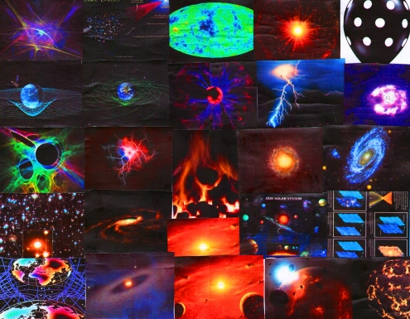

The first of the mood boards….
March 10, 2012 at 4:43 pm (Day to day updates of my project research and development) · Edit
I mentioned a few posts ago that I wanted to create mood boards to help me get a visual feel of the book and what colours would work best for different areas of the book. These first two deal with the chapter on the hominid family, or the Homo genus species. It helps, at a glance to see the faces up close and also a few images of what the hominids did to survive in their environment…
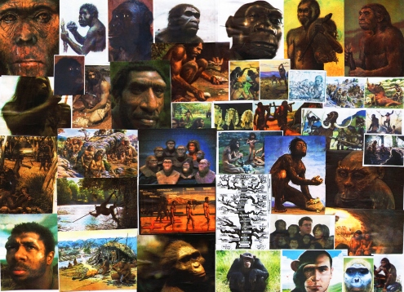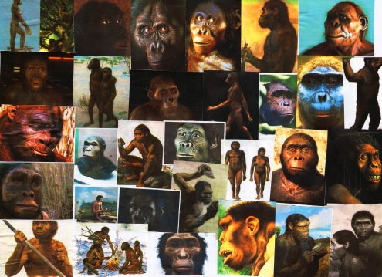
Original colour style for book
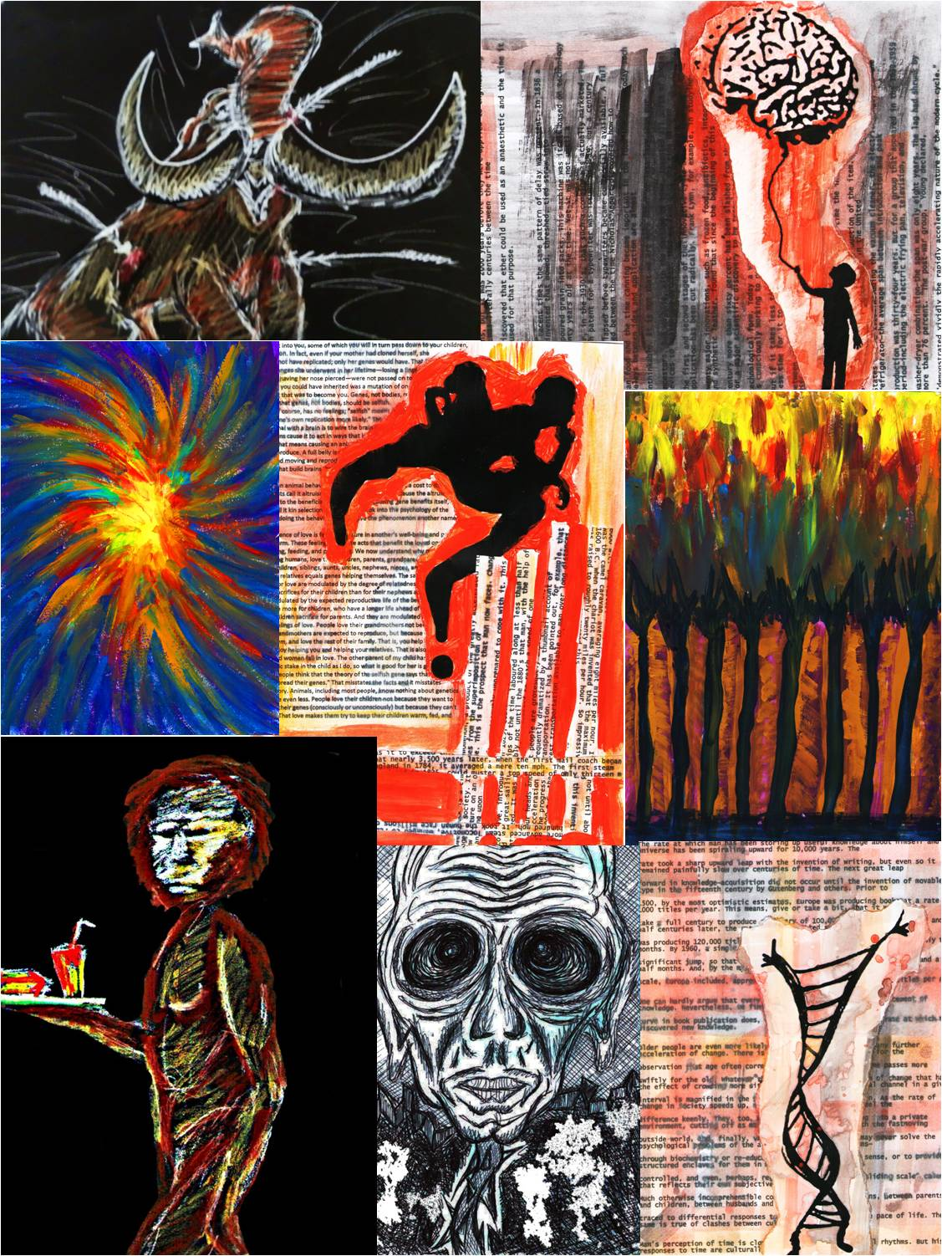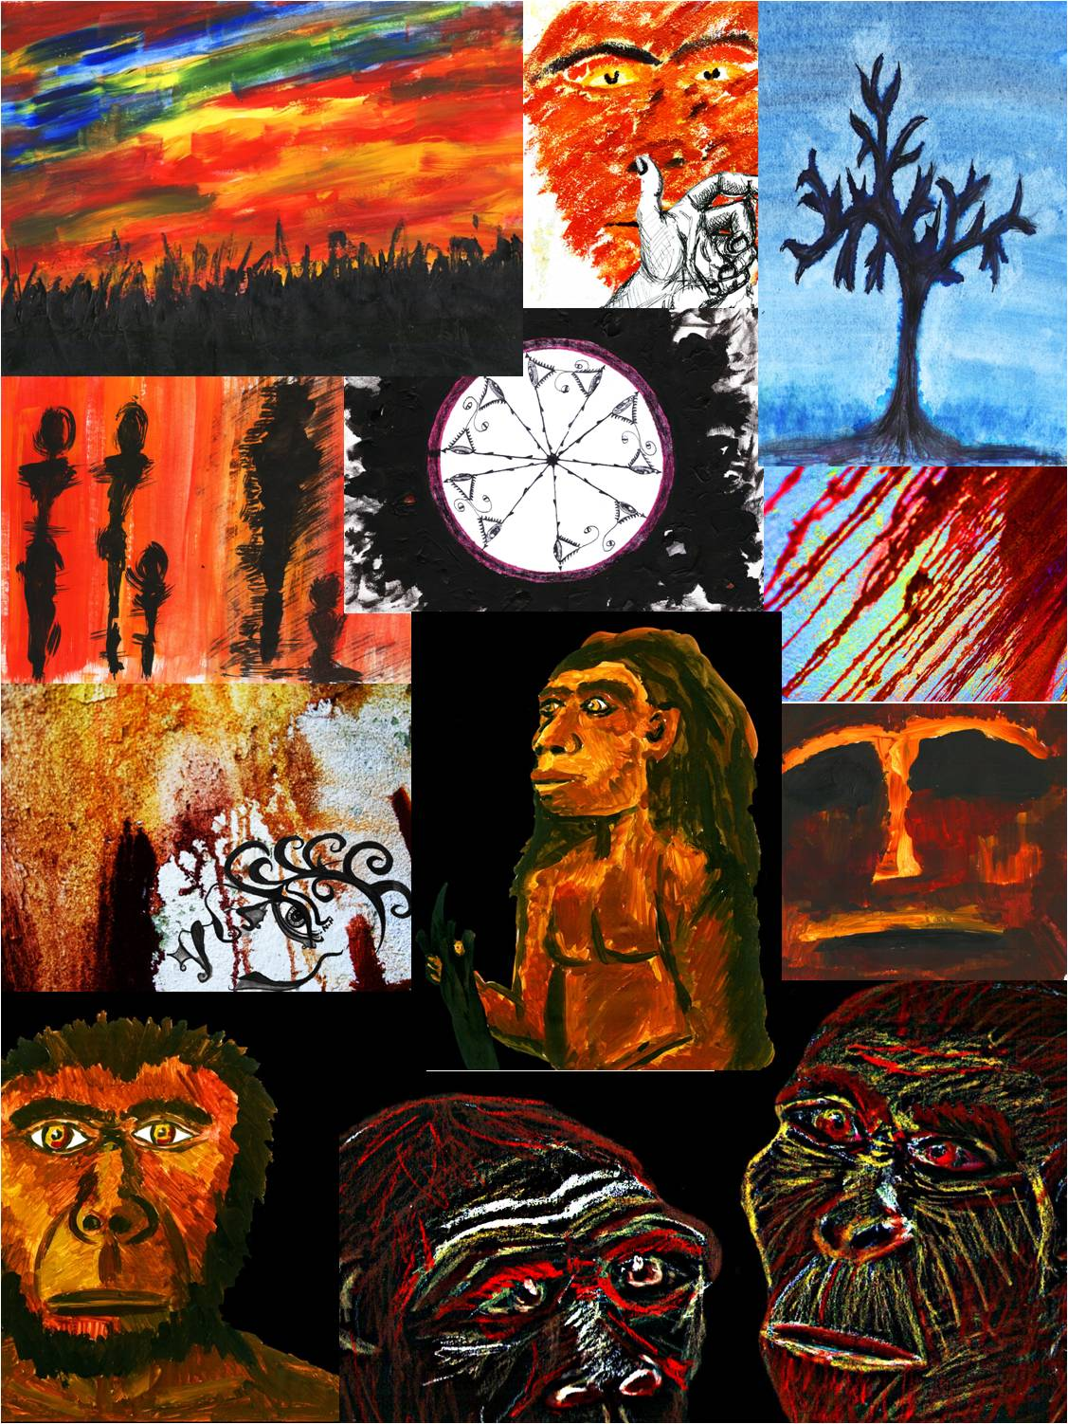
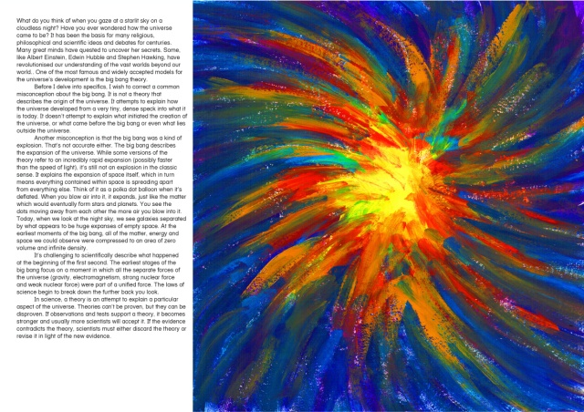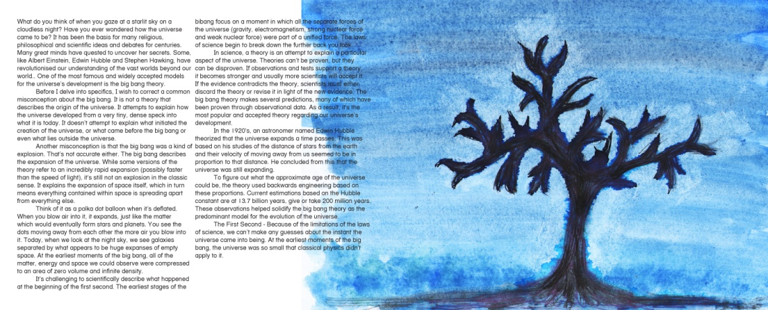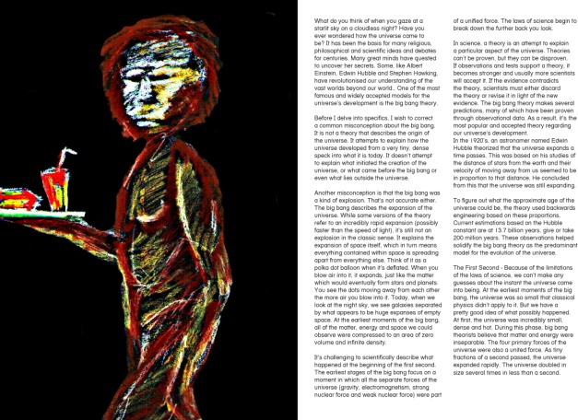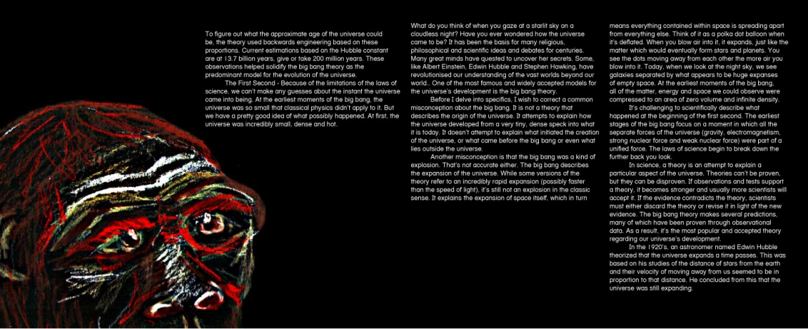
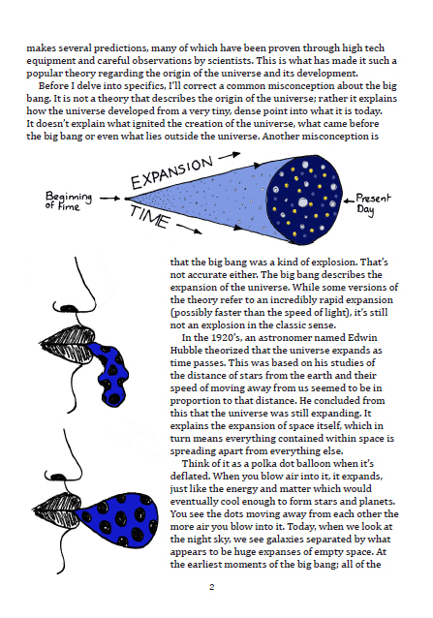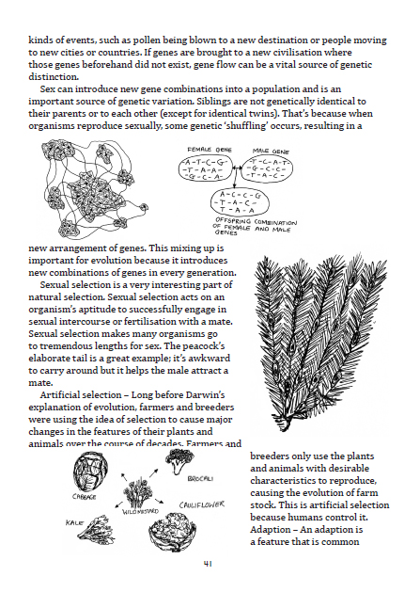

APPENDIX C: Excommunicated religious chapter
Chapter 13 – The religion versus science conflict
Friction between religion and supporters of evolution comes to a brink when parties from both sides speak of things that they may not be fully equipped to speak about. Scientists are no longer functioning as scientists when they make claims about the ultimate nature of reality and religious adherents make a mistake when they turn their sacred texts, written for theological purposes, into a template for scientific inquiry.
The following quotations indicate the range of beliefs about the conflict and harmony between science and religion;
“There has to be no conflict between true science and true religion, because they both describe reality” – Anon.
“Sciences respond to a felt need to understand the world, and religions respond to a felt need for the world to have meaning” – Statement by the Centre of Study of Science and Religion.
“After religious teachers accomplish the refining process indicated, they will surely recognise with joy that true religion has been ennobled and made more profound by scientific knowledge” – Albert Einstein
Extract from the better angels of our nature by Steven Pinker – Modern biblical scholars have established that the bible is a wiki. It was compiled over five hundred years ago from writers with different styles, dialects, character names and conceptions of god, and it was subjected to haphazard editing that left it with many contradictions, duplications and nonsensical writings. (It was also written , the new testament anyway, about a ‘divine messiah’ who was murdered 1500 years before anyone thought to lift a pen and write about it, another sure cause of misleading historical reference.)
The bible is one of the most violent compilations ever published and distributed. (Add more to this.) Ironically it’s referred to as the ‘Good Book’ and is the bestselling book in existence. But this discussion is not to accuse Christians of endorsing torture and persecution. The question is why they don’t, given that their beliefs imply that it would serve the greater good. The answer is that people in the West today catalogue their religious ideology. When they affirm their faith in houses of worship, they profess beliefs that have barely changed in two thousand years. But when it comes to their actions, they respect modern norms of nonviolence and toleration, a considerate duplicity for which we should all be grateful.
Why do we believe in gods?
If you understand the composition of a Big Mac meal then you can understand the composition of religion. We evolved adaptations for things that were crucial and rare for our survival; sugars of ripe fruits, fat of lean game meat and salt. The modern world creates a narrative form of it which derives from these adaptations and place supernatural needs in the place of physical needs. There is a very powerful human need for something to base their lives upon, something to work towards, to look to guidance for and receive assurance from. There is a widespread human need to have a purpose in life and a belief that there is an afterlife that we are special, that we are exceptions to the recycling of life; our bodies may decompose but our souls travel to a spirit realm where we are reunited with one another. Why do we have these needs? What evolutionary purpose did they serve?
Morality and religion differ in the sense that morality is doing what is right, regardless of what we are told. Religious dogma is doing what we are told, no matter what is right.
When humans are unknowing and confused they make theories in order to solve things. In years to come these theories are usually proven false and it takes generations to believe the proof. One such example is the sun revolving around the earth. We now know that this theory is false, the earth revolves around the sun. I feel that religion is the same. Humans were confused about how we came about, and needed something to lean on to erase that unknowing. They came up with the idea that we were placed here by something greater than life itself. Science has proven evolution in so many different ways. It will take many generations before the world sees this.
There is also the theory that the world was flat that has been disproven. There are so many other reasons why people need religion, not only the beginning our existence. Here are just a few of them: a moral reminder, the idea that we are not alone to struggle through life, the idea that there is some higher purpose to our existence, and that there is life after death for us and our loved ones. To provide substitutes, there are evolutionary morals and the meaning of life defined by contentment and love. But, with evolution, this also means that we just don't exist after we die. As much as I like evolution, it is another one of those theories that is compelling yet hard to prove or disprove. Religion is more than a handful of ideas, just as the need for it is equally complicated. The need is strong, and hard to dismantle.
I think that it must stem from some innate need for a parental figure. The need to feel controlled; or rather have a dominant figure in one's life. When we grow up, there is a need for structure, which is usually provided by the parents, and in most cases, it is the father who enforces things, while the mother is more nurturing. when we are grown, we lack that in our lives, for the most part. so perhaps god is that nurturing and guiding power that people lack otherwise. It’s something that they can look up to, once they have lost their innocent idea that their parents are the strongest, truest and most perfect people in the world. god is omniscient, according to many that believe in a god.
Regardless whether there is a God or not, people have a burning desire to search for one. Why is that? Maybe God has instilled something in us or pushes us towards Him every once in a while. But, on a more practical stand, people need to have security in the unknown. They need somewhere to run to with their fears, ignorance, and their problems. Some examples of our ignorance are the concepts of infinity and nothingness. Non-existence outside the realm of life is a scary thought, for ourselves and our loved ones. Life is uncertain and people need something they can count on. So, if there is a God then he fills these voids. And if there isn't, the belief that he does exist serves the same purpose. I think most of what people call encounters of God can be explained psychologically.

APPENDIX D: Survey results,comparisions, summeries and conclusions.
I surveyed one hundred people by using an online survey link through my facebook account and also by handing out questionnaires in my university.
Results
1)

Interestingly, two people said they were neither religious nor spiritual but did believe in life after death.
2)

Three people said they were religious or spiritual but did not believe in life after death
3)

- “Non-believer, I find the idea being an all knowing being fine, but I don't think there is some guiding hand in life leading us.

4)

I was delighted to see such a vast favour of science/history topics; most people stated they enjoyed both. This would be a key factor in seeing the potential for my book.
5)

- Many amusingly said they thought it was a great TV show!
- A lot of people thought it was a big bang that formed earth
- Some thought it was a science theory that explained how life began

6)

Many mentioned their idea of the common misconception that humans evolved from monkeys

7)

Many who answered that they were religious/ spiritual went on to admit knowing very little about the big bang or evolution still but said they agreed with Darwin’s theory despite their lack of knowledge on the subject. One said that although they were religious, the found a lot of the bible’s teaching farfetched whereas Darwin shows a lot of logic.
8)

- “Inherit the Wind”

- “Darwin’s – ‘Origin of the Species’ and some of Dawkins’ like ‘The God Delusion’”.

- “When I was a kid yeah, I read children's encyclopaedias about it. I can't remember the names though”.

- “Yes. Too many to list them all.”

- “Indirectly, yes. ‘The God Delusion’ by Richard Dawkins touches on the subject.”

9)

- “No, there was a lot of unnecessary waffle in them”.

10)

- “Having not read anything, maybe this is where the market exists; to make something much easier to read, something that looks much more commercial to attract the reader.”

11)

Many have several of these devices
12)

- “No. I am a bit old fashioned and prefer a real book!”

- “No, but I have downloaded books in PDF format to read on my laptop”.

- “Yes I have, especially for my course at University”.

13)

- “No. I feel it’s a novelty and will die down”

- “I think there is a place for them but there is something nice about being able to life a book and read off a black and white page in such a digital age”.

- “Yes, definitely”

- “Certainly a big part of the future but won’t completely replace paper books”.

- “Yes, they are so much cheaper for students”.

- “Yes and no. I still love really books but some books are too heavy and eBooks allow for easier access. I think both”.

- “Yes because they are an increasingly more viable way of exploring and acquiring material based on ones interests”.
14)

A few people went on to say that illustrated books are excellent for helping readers to understand the words better.
- “Illustrations always help”.

- “Yes, I do because at least it breaks up the book so it doesn't seem as dull or as long”.

- “For informative books, yes”

- “Illustrated is preferable”

15)

- “Yes it would give a greater understanding”

- “Definitely, I think it would be the first thing to draw my attention to it!”

- “Most definitely, I think any book of an educational or informative manner is enhanced by illustration”.

- “Definitely as it's a subject that most people don't totally get”.

- “I think that would depend on the reader. I myself, if the illustrations were clear and had a valid reason in being present, would be in favour”.

- One person said that they think many people disagree with evolution because they don’t understand it and that an illustrated book could help clarify things for them.

Comparisons
I’ve noticed a common pattern between answers to questions’ 1, 5, 6, 7 and 15. One answered that they were very religious, they know ‘enough’ about the big bang and evolution and they ‘disagreed’ with Darwin’s theory. Finally they ‘disagreed’ that an illustrated eBook on evolution could promote a better understanding of it.
Two people said that they were very Christian. They stated that the big bang theory was ‘against Christian beliefs’. When asked what they knew about evolution, they answered that ‘we were meant to have evolved from monkeys’. They disagreed with Darwin’s theory of evolution but strangely ‘agreed’ that an illustrated book on the subject ‘could’ promote a better understanding of it!
Two other people said they were ‘religious’, that what they knew of the big bang and evolution came only from what they were taught in school but that it contradicted their religious beliefs. Strangely though, they ‘partially’ agreed with Darwin’s theory of evolution and agreed that an illustrated book on evolution ‘could’ promote a better understanding of it.

Summery
It was clear to me from many of the answers given in questions five and six that the big bang theory evolution either weren’t given the attention they deserved by teaching authorities or that people just weren’t sure exactly what evolution was. It’s a common misconception held by people that we evolved from monkeys. We, in fact, evolved from a creature that was neither human nor chimpanzee. It was a common ancestor to both our lineages.
I was delighted to see that most people weren’t in total agreement with their religious/spiritual beliefs and completely agreed with Darwin’s theory of evolution. One particular answer summed up this perfectly. They said;
“Although I’m religious, I find some of the Bible’s teachings farfetched whereas Darwin shows a lot of logic”
Only 20% had read about the subject of evolution and went on to say they thought many of the books were ‘complicated and had ‘a lot of unnecessary waffle in them’. They thought more imagery and more ‘to the point’ and ‘engaging’ writing could encourage more readers into this subject. One fantastic answer took the words right out of my mouth. This was answered by someone who hadn’t read any books on the subject but helpfully suggested;
“Having not read anything, maybe this is where the market exists; to make something much easier to read, something that looks much more commercial to attract the reader”
These are my thoughts exactly and primarily why I’m undertaking this project. As I’d predicted, most people had at least one device that they could read eBooks from. One person said they found their kindle to be an excellent tool for accessing and storing reading material for their university course.
When asked whether they thought digital books are the future of book reading, the majority said yes. Many of those who disagreed said they preferred the feel of a real book and a few others believed that the eBook craze was just a novelty and would settle down again.
Most people preferred illustrated books to plain ones, saying they feel it breaks up the text well and makes the book seem less dull and long.

Conclusion
Finally, I was greatly encouraged by the vast majority of people who agreed that an illustrated eBook on the subject of evolution would promote a better understanding of it. Some said ‘it would be the first thing to draw my attention to it’. One person cleverly said that they think many people disagree with evolution because they don’t understand it and that an illustrated book could help clarify a few things for them.

APPENDIX E: August review questionnaire
Introduction
In August 2012, I asked twenty people from different professional backgrounds to review the first chapter of my eBook. I handed out review questionnaires to several marketing professionals, a few enthusiastic science book readers, a journalist, peer designers and a few others that just haven’t much previous knowledge on the subject. The following are pie charts of the results followed by a summery and conclusion.
1)
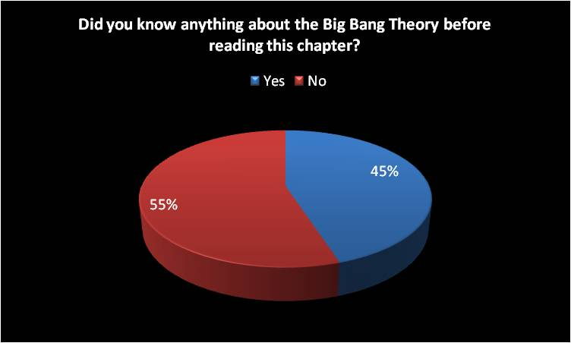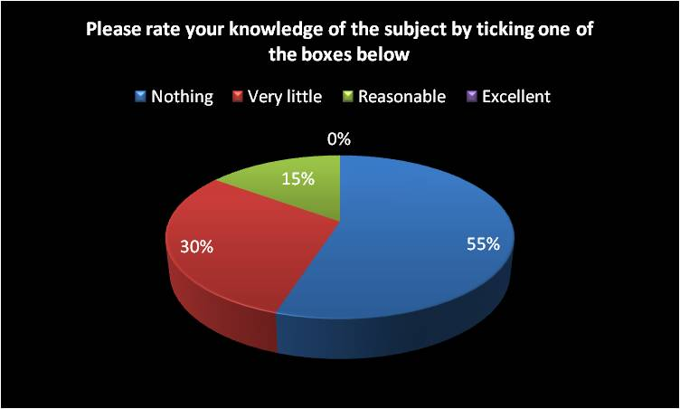

2)
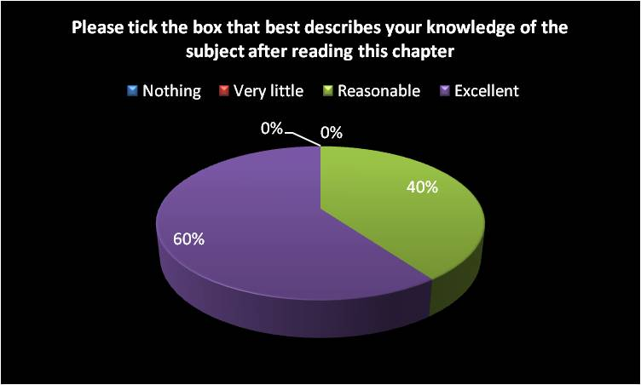
3)
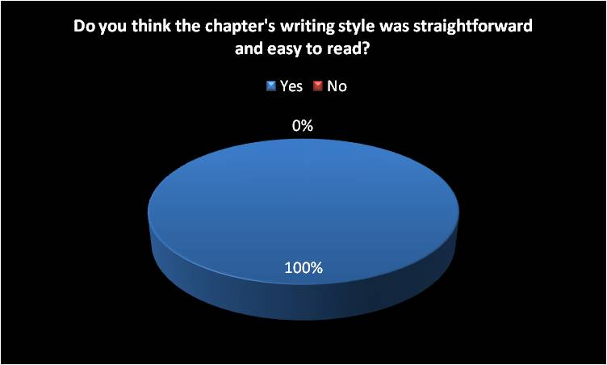
- “Yes, it really helped me to understand the need-to-know information about the Big Bang Theory”
- “Yes. I’ve read several books on the subject and this chapter described it in a fresh and interesting way”.
- “Yes. I’ve never read anything about the Big Bang Theory that’s been so relaxing to read. It’s usually long-winded and confusing”.
4)
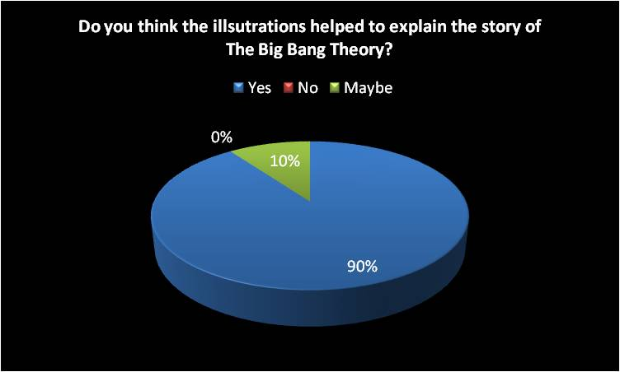
- “It’s too hard to understand this subject through words alone; the illustrations were nicely drawn and easy to understand”.
- “Yes. The chapters were much easier to read because of the illustrations. They had a nice light, simplistic style”.
- “Yes, they broke up the text nicely too”
- “Maybe. They’re nicely drawn and broke up the text well but I think the writing itself explains the story well enough”.
5)
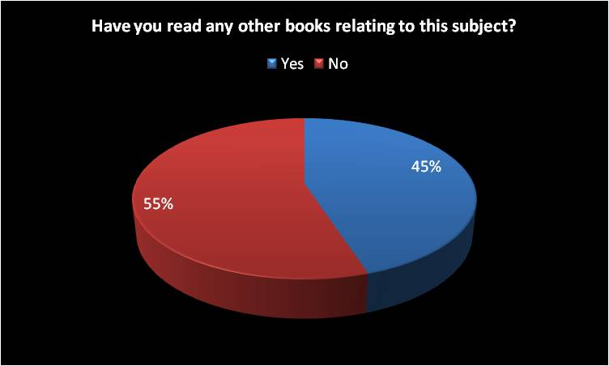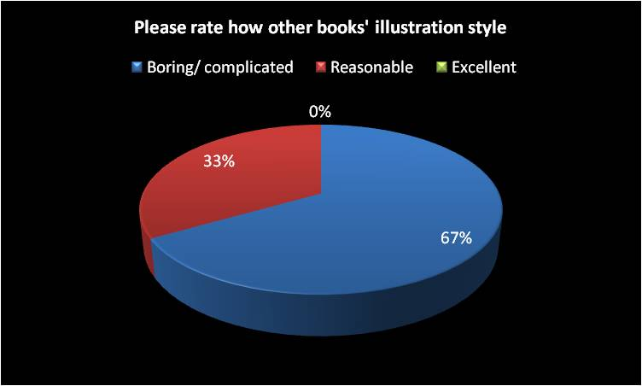
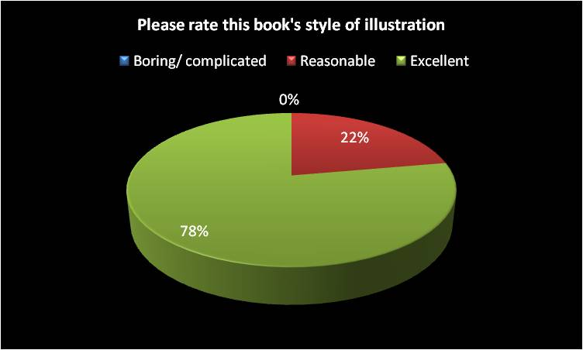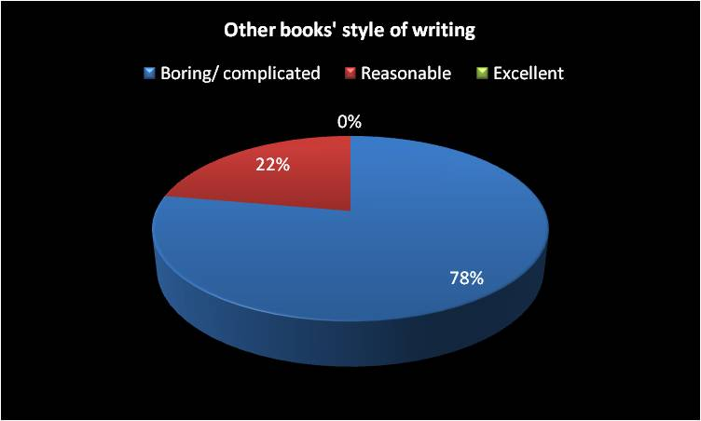
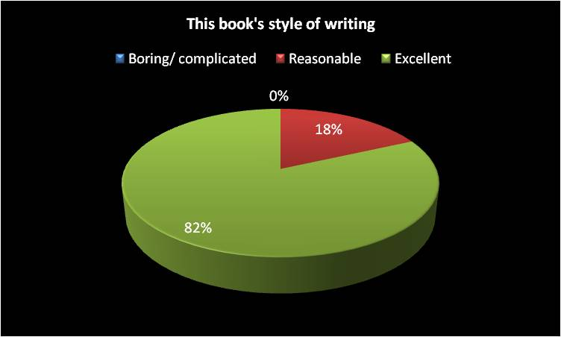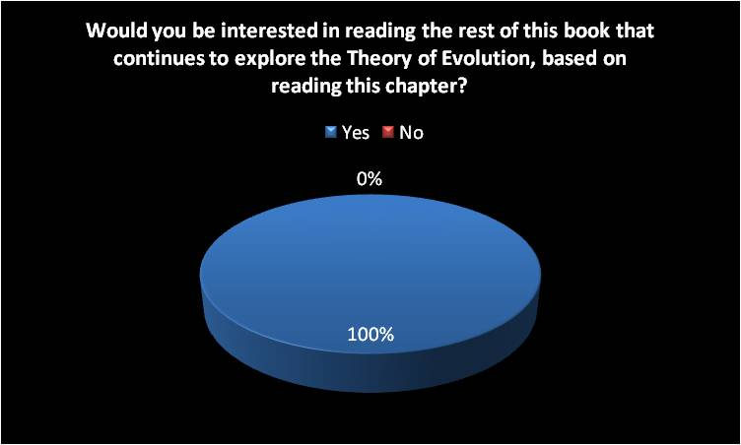
6)
- “This chapter alone has helped me understand a lot of things I previously didn’t have a clue about. I’d love to learn more about evolution as well”.
- “Yes. I don’t really know anything about the Theory of Evolution either and would like to learn about it”
- “Yes. I wish I had the rest of the book to read now!
7)

- “Yes, this book would be perfect for them”.
- “Yes. I have always been interested in the subject but never thought I would be able to understand it. It seemed too complicated, but this book makes it so easy to read about”.

- Please feel free to add any additional comment based on your reading of this chapter
- “This chapter is anything but daunting, it’s exciting to read and easy to understand. I’d defiantly buy this book to read the rest of it.”
- “I think this chapter, and probably the rest of the book, would be a great introduction to the Big Bang Theory and the Theory of Evolution. With a basic understanding, some novice readers might be inspired to study more deeply into certain topic areas mentioned.”
- “This sample chapter describes all you need to know in a clear, concise and fresh new way”.
- “I would certainly buy this book after reading the first chapter; it’s not intimidating like other books already out there on the subject”.
- “I like how different this book is in comparison to other books based on the same subject. I’ve never seen anything quite like this; it’s exciting!”
- “This book targets a new readership market. It’s a beginner’s book for adults that may know nothing about the Big Bang Theory or the Theory of Evolution but want to learn about it in an exciting way.
- “Although I had previously understood a lot of the information described in the sample first chapter, I much preferred this style of writing. I wish I had read something like this before reading other complicated books on the subject”
- “I was drawn in by the book title and cover illustration immediately. It’s so clever and interesting to look at, and the sample chapter didn’t let me down, very enjoyable and informative”.
- “Very impressed with the first chapter and love the illustrations, so original!”
Summery
Question one asked if people knew anything about the Big Bang Theory before reading this chapter. 55% said no. Of the 45% who said yes, the vast majority admitted to knowing very little and a few said they had a reasonable amount of knowledge on the subject.
Question two asked people to rate their knowledge of the Big Bang Theory after reading and looking at the illustrations in the first chapter. 60% rated their new knowledge level as excellent and 40% rated their new knowledge level as reasonable.
Question three asked if people thought the chapter’s writing style was straightforward and easy to read. All twenty respondents said yes. One person added
“I’ve never read anything about the Big Bang Theory that’s been so relaxing to read. It’s usually long-winded and confusing”.
Question four asked if people thought the accompanying illustrations helped to explain the story of the Big Bang Theory. 90% said yes and 10% said maybe. One respondent said;
“Yes. The chapter was much easier to read because of the illustrations. They had a nice light, simplistic style”.
Question five asked if people had read any other books relating to the subject of the Big Bang Theory or evolution. 55% said no and 45% said yes. Those who said yes went on to rate other books to this one. When asked to rate other books’ illustration style, 67% said they were boring or complicated and 33% said they were reasonable. When asked to rate this book’s illustration style, 78% of people thought they were excellent and 22% thought they were reasonable.
When asked to rate other books’ writing style, 78% said they were boring or complicated and 22% said they were reasonable. When asked to rate this book’s style of writing, 82% thought it was excellent and 18% thought it was reasonable.
Question six asked if they would be interested in reading the rest of the book based on reading the first chapter. 100% said yes. One respondent added;
“This chapter alone has helped me understand a lot of things I previously didn’t have a clue about. I’d love to learn more about evolution as well”.
Question seven asked if they thought this book, based on the first chapter appeals to people that know little or nothing about the Big Bang theory or evolution and want to learn about it in a clear and interesting way. 100% said yes. One person said;
“I have always been interested in learning about the subject but never thought I would be able to understand it. It seemed too complicated but this book makes it so easy to read about”
Question eight asks people to add any additional comments based on their reading of the chapter. See comments above.

Conclusion
The results of this questionnaire clarify everything I aimed for with this book. I was greatly encouraged by the positive responses from a marketing, journalistic, design and book reading point of view. This illustrated eBook is unique in style, it has a definite marketing potential and it has achieved everything I’d wanted for it at this stage. The review of chapter one has spurred me on confidently to the advertising stage of this book.

APPENDIX F: Examples of illustrated book on evolution targeted at children
