Temporal Relations in Visual Semantics of Verbs
Minhua Ma and Paul Mc Kevitt¹

Abstract. Numerous temporal relations of verbal actions have been analysed in terms of various grammatical means of expressing verbal temporalisation such as tense, aspect, duration and iterations. Here the temporal relations within verb semantics, especially ordered pairs of verb entailment, are studied using Allen’s interval-based temporal formalism. Their application to the decomposite visual definitions in our intelligent storytelling system, CONFUCIUS, is presented, including the representation of procedural events, achievement events and lexical causatives. In applying these methods we consider both language modalities and visual modalities since CONFUCIUS is a multimodal system.

Keywords: natural language understanding, knowledge representation, temporal relations, visual semantics, language visualisation, verb semantics

1 INTRODUCTION
There are two main kinds of temporal reasoning formalisms in artificial intelligence systems: point-based linear formalisms to encode relations between time points (moments), and interval-based temporal calculus to encode qualitative relations between time intervals [1]. Point-based linear formalisms can represent moments, durations, and other quantitative information, whilst interval-based temporal logic can express qualitative information, i.e. relations between intervals.
A common problem in the tasks of both visual recognition (image processing and computer vision) and language visualisation (text-to-graphics) is to represent visual semantics of action verbs (events), which happen in both space and time continuum. Since states and events are two general types of verbs and events usually occur over some time intervals and involve internal causal structure (i.e. change of states), we use an interval-based formalism rather than a point-based formalism to represent temporal relationships in visual semantics of eventive verbs.
First, we begin with background to this work, the intelligent multimodal storytelling system, CONFUCIUS, and review previous work on temporal relations in story-based systems and natural language processing (section 2). Then we investigate various temporal interrelations between ordered pairs of verb entailment using this interval-based formalism in section 3. We turn next to discuss some attributes of interval relations and revise the conventions to indicate directions for causal relationship and backward presupposition in section 4. Next we apply this method in our visual definitions of verbs in CONFUCIUS and discuss its applications in different circumstances such as procedural events, achievement events and lexical causatives in section 5. Following this, comparisons of our method to other work are considered (section 6), and finally section 7 concludes with a discussion of possible future work of adding quantitative elements to the decomposite visual representation.

2 BACKGROUND AND PREVIOUS WORK
Our long-term objective of this research is to create an intelligent multimedia storytelling interpretation and presentation system called CONFUCIUS, which automatically generates multimedia presentations from natural language input. It employs temporal media such as 3D animation and speech to present short stories. Establishing correspondence between language and animation is the focus of this research. This requires adequate representation and reasoning about the dynamic aspects of the story world, especially about events, i.e. temporal semantic representation of verbs.

2.1 CONFUCIUS
Any multimodal presentation system like CONFUCIUS needs a multimodal semantic representation to allocate, plan, and generate presentations. Figure 1 illustrates the multimodal semantic representation of CONFUCIUS. Between the multimodal semantics and each specific modality there are two levels of representation: one is a high-level multimodal semantic representation which is media-independent, the other is media-dependent representation which bridges the gap between general multimodal semantic representation and specific media realization and is capable of connecting meanings across modalities, especially between language and visual modalities. CONFUCIUS uses a decomposite predicate-argument representation [7] to connect language with visual modalities as shown in Figure 1. The interval-based temporal logic we discuss in this paper is applied in the decomposite visual representation which is further discussed in section 5. This method is suited for representing temporal relations and hence helping create 3D dynamic virtual reality in language visualisation.

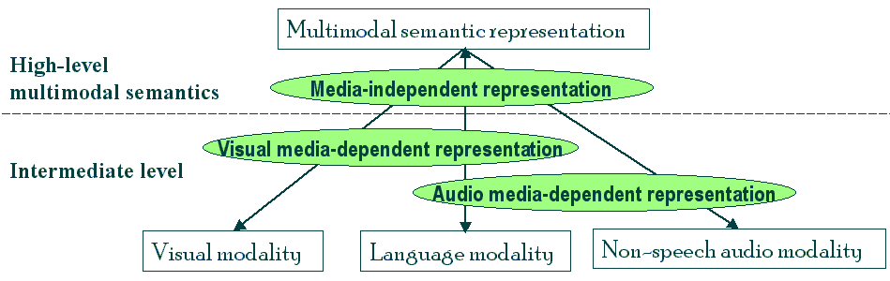

Figure 1. Multimodal semantic representation of CONFUCIUS

Figure 2 shows the knowledge base of CONFUCIUS that encompasses language knowledge for the natural language processor to extract semantic structures from text, and visual knowledge which includes object model and event model, etc. The event model consists of visual representation of events (verbs) that contains explicit knowledge about the decomposition of high level acts into basic motions, and defines a set of basic animations such as walk, jump, crouch by determining key frames of corresponding rotations and movements of human joints and body parts involved.

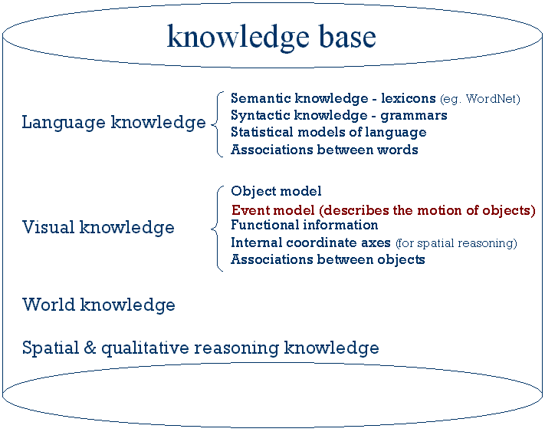

Figure 2. Knowledge base of CONFUCIUS

Here we focus on an efficient temporal representation in event models of this knowledge base, exploring how to apply interval relations in modeling the temporal interrelation between the subactivities in one event.

2.2 Previous work on temporal relations
Here we introduce Allen’s [1] thirteen basic interval relations (Table 1), which will be used in visual semantic representation of verbs in CONFUCIUS’ language visualisation.
Allen’s interval relations has been employed in story-based interactive systems [8] to express progression of time in virtual characters and handling linear/ parallel events in story scripts and user interactions.
On sentence level temporal analysis within natural language understanding, there are extensive discussions on tense, aspect, duration and iterations. The times involved are the time of speech, the time of situation and the time of reference (i.e. those denoted by time adverbials such as “yesterday”, “next Monday”). To represent the relations among them, some use point-based metric formalisms, some use interval-based logic, others integrate interval-based and point-based temporal logic [6] because of the complexity of temporal relations in various situations, for example, the distinction between punctual events and protracted events, achievements and accomplishments [11, 12], stative verbs and eventive verbs, states, events and activities [2]. However, few of these are concerned with the temporal relations at the lexical level, e.g. between or within verbs. In lexical semantics, extensive studies have been conducted on the semantic relationship of verbs [4], but few temporal relations have been considered. The closest work to ours presented in this paper was developed about 6 years ago by Badler et al. [3]. They generalized five possible temporal relationships between two actions in technical orders (instruction manuals) domain. In the following sections we investigate temporal relations at the lexical level since this work will facilitate our decomposite visual definitions of verbs in language visualisation.

Basic relations |  | Example | Endpoints
precede | x p y | xxxx  yyyy | x_{e} < y_{s}
inverse precede | y p⁻¹ x | xxxx  yyyy | x_{e} < y_{s}
meet | x m y | xxxxx  yyyyy | x_{e} = y_{s}
inverse meet | y m⁻¹ x | xxxxx  yyyyy | x_{e} = y_{s}
overlap | x o y | xxxxx  yyyyy | x_{s} < y_{s} < x_{e} ∩  x_{e} < y_{e}
inverse overlap | y o⁻¹ x | xxxxx  yyyyy | x_{s} < y_{s} < x_{e} ∩  x_{e} < y_{e}
during | x d y | xxxx  yyyyyyyyy | x_{s} > y_{s} ∩  x_{e} < y_{e}
inverse during (include) | y d⁻¹ x | xxxx  yyyyyyyyy | x_{s} > y_{s} ∩  x_{e} < y_{e}
start | x s y | xxxxx  yyyyyyyyy | x_{s} = y_{s} ∩  x_{e} < y_{e}
inverse start | y s⁻¹ x | xxxxx  yyyyyyyyy | x_{s} = y_{s} ∩  x_{e} < y_{e}
finish | x f y | xxx  yyyyyyyy | x_{e} = y_{e} ∩  x_{s} > y_{s}
inverse finish | y f⁻¹ x | xxx  yyyyyyyy | x_{e} = y_{e} ∩  x_{s} > y_{s}
equal | x ≡ y  y ≡ x | xxxxx  yyyyy | x_{s} = y_{s} ∩  x_{e} = y_{e}
Table 1. Allen’s thirteen interval relations

3 TEMPORAL RELATIONS IN VERB ENTAILMENTS
In this section various temporal relations between ordered pairs of verbs in which one entails the other are studied and their usage in visualisation is discussed.
Verb entailment is a fixed truth relation between verbs where entailment is given by part of the lexical meaning, i.e. entailed meaning is in some sense contained in the entailing meaning. Verb entailment indicates an implication logic relationship: “if x is true, then y is true” (x⇒y). Take the two pairs snore-sleep and buy-pay as example, we can infer snore⇒sleep and buy⇒pay since when one is snoring (s)he must be sleeping, and if somebody wants to buy something (s)he must pay for it, whilst we cannot infer in the reverse direction because one may not snore when (s)he is sleeping, and one might pay for nothing (not buying, such as donation). In these two examples, the entailing activity could temporally include (i.e. d⁻¹) or be included in (i.e. d) the entailed activity. Fellbaum [4] classifies verb entailment relations into four kinds, based on temporal inclusion and other elements between the activities such as causal structure (Figure 3).
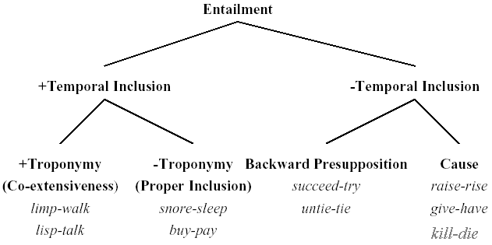

Figure 3. Fellbaum’s classification of verb entailment

Troponymy is one important semantic relation in verb entailment [4] which typically holds between manner elaboration verbs and their corresponding base verbs, i.e. two verbs have the troponym relation if one verb elaborates the manner of another (base) verb. For instance, mumble-talk indistinctly, trot-walk fast, stroll-walk leisurely, stumble-walk unsteadily, gulp-eat quickly, the relation between mumble and talk, trot/stroll/stumble and walk, gulp and eat is troponymy. In CONFUCIUS, we use the method of base verb + adverb to present manner elaboration verbs, that is, to present the base verb first and then, to modify the manner (speed, the agent’s state, duration of the activity, and iteration) of the activity. To visually present “trot”, we create a loop of walking movement, and then modify the cycleInterval to a smaller value to present fast walking.
In Table 2 we analyze the possible temporal relations between these verb entailments and give some examples. Notice that the interval relation between a troponym pair of verbs is {≡} (see Table 1), e.g. limp ≡ walk.
The relation set of {p,m,o,s,f⁻¹,≡} may hold in any pair with causal structure (i.e. lexical causatives), between the eventive verb and its result state (either stative verb or adjective), such as give-have, eat-full, work-getPaid, heat-hot. Thanks to the productive morphological rules in English deriving verbs from adjectives via affixes such as –en and –ify, these deadjectival verbs, e.g. “whiten”, “shorten”, “strengthen”, “soften”, often refer to a change of state or property and have the meaning (make/become/cause + corresponding adjective). The temporal relation between the pair of deadjectival verbs and the state of their corresponding adjectives is also {p,m,o,s,f⁻¹,≡}. For instance, the possible interval relations set between soften-soft could be soften {p,m,o,s,f⁻¹,≡} soft. Similarly, the relation set {p,m,o,s,f⁻¹,≡} is also applicable to cognate verbs and adjectives such as beautify-beautiful and clarify-clear.
Verb entailment relations | Temporal relations | Example
troponym | {≡} | limp ≡ walk
non-troponym  (proper temporal inclusion) | {d,d⁻¹} | snore d sleep  buy d⁻¹ pay
backward presupposition | {p⁻¹,m⁻¹} | untie p⁻¹ tie ∪  untie m⁻¹ tie
cause | {p,m,o,s,f⁻¹,≡} | eat p fullUp ∪  eat o fullUp,  give m have,  build o exist
Table 2. Temporal relations in verb entailments
Eventive verbs, which have internal causal structure and are distinguished from stative verbs on this point according to Gennari and Poeppel [5], are also our main concern in our language visualisation.

4 SOME ATTRIBUTES OF INTERVAL RELATIONS
Reversibility and transitivity are important attributes in temporal reasoning. They provide an algorithm which propagates the temporal relations through a collection of intervals, determining the most constrained disjunction of relations for each pair of intervals which satisfies the given relations and is consistent in time. By adding directions to interval relations we may denote the implication logic relationship between two events.

4.1 Reversibility and transitivity
Reversibility of one interval relation could be defined as: if ∃R: act1 R act2, R∈{p,p⁻¹,m,m⁻¹,o,o⁻¹,d,d⁻¹, s,s⁻¹,f,f⁻¹} ⇒ act2 R⁻¹ act1, then this temporal relation R is reversible. For instance, untie p⁻¹ tie ⇒ tie p untie. All interval relations except ≡ are reversible.
Transitivity of one interval relation could be defined as: if ∃R: (act1 R act2) ∩(act2 R act3), R∈{p,p⁻¹, o,o⁻¹,d,d⁻¹, s,s⁻¹,f,f⁻¹,≡}⇒ act1 R act3, then this temporal relation R is transitive, to wit, the temporal relations between the pairs of intervals can be propagated through the collection of all intervals. For instance, born p age, age p die  born p die. Notice that m and m⁻¹ are not in the set of possible transitive relations, because the nature of these two relations is not transitive, i.e. (act1 m act2) ∩ (act2 m act3) ⇒ ~(act1 m act3). All the other temporal relations {p,p⁻¹,d,d⁻¹,s,s⁻¹,f,f⁻¹,≡} must be transitive except o and o⁻¹ since act1 o act3 cannot be inferred from (act1 o act2) ∩ (act2 o act3), though it might be true.
The temporal reasoning of the interval relations can be obtained by computing the possible relations between any two time intervals. For instance,
(x d⁻¹ y) ∩ (y p z) ⇒ x R z, R∈{p,o,d⁻¹,f⁻¹,m}
In this case, x could be the activity “buy”, y could be the activity “pay” and z could be “consume”.

4.2 Revised interval relation conventions
Here we revise Allen’s interval logic by adding directions of implication logic relationships to it, using R>, <R, or <R>, R∈{p,p⁻¹,m,m⁻¹,o,o⁻¹,d,d⁻¹,s,s⁻¹,f,f⁻¹,≡}. Hence, limp > walk indicates their troponomy relation, and <≡> indicates synonym relations like speak <≡> say, or same activity from different perspectives such as teach <≡> learn, buy <≡> sell.
By this facility we may also use build o> exist to indicate causal relationship (in prediction), and use tie <p untie to indicate backward presupposition (in planning).

5 APPLICATION OF INTERVAL REPRESENTATION
The interval temporal logic discussed above can be applied in a decomposite predicate-argument model of visual definition [7] to represent the temporal relationship between subactivities. The relationship between the definiendum verb and the defining subactivities is temporal inclusion (whether proper inclusion or not), i.e. act1 R act2, R∈{d,s,f,≡}, act1 is part of, or a stage in, temporal realization of act2, and hence it could be one sub-activity in act2’s visual definition. ≡ is a special case. If there is only one subactivity in a definition and the relation of this subactivity and its defined verb is ≡ or ≡>, the definition is rather an interpretation than a semantic decomposition, e.g. in the definition slide():- move(), the temporal relation between the subactivity and definiendum is slide ≡ move. Because “slide” is a troponym of “move”, i.e. slide ≡> move, we can use “move” to define “slide” but not use “slide” to define “move”. The relationship between any subactivity and the verb sense it defines are {d,s,f,≡}:
act():-
subact1(), ……
subacti(), …….
subacti R act, i∈N, R∈{d,s,f,≡}
In the proposal of Ma and Mc Kevitt [7] there are two symbols indicating temporal relations between subactivities. The comma separating two sub-activities in sequential order. “act01, act02” means that act02 follows act01. This temporal relation could subsume several relations {p,m,o,f⁻¹,d⁻¹} in interval logic, i.e. all temporal relations in x R y while x_{s} < y_{s}, though p and m are the most frequent relations denoted by comma. Figure 4 shows the visual definition of “call” in Ma and Mc Kevitt [2003] (Figure 4a) and the improved definition using interval logic (Figure 4b). In addition, semicolon is used to indicate the equal temporal relation ≡ between two activities which occur simultaneously. “act01; act02” means that act01 and act02 start and finish at the same time. This temporal relation is usable for defining verbs such as rolling of a wheel (Figure 4c, d).
call(a):-
pickup(a, tel.receiver, a.leftEar),
dial(a, tel.keypad),
speak(a, tel.receiver),
putdown(a, tel.receiver, tel.set).
a. Visual definition of “call” in Ma and Mc Kevitt [7]
call(a):-
pickup(a,tel.receiver,a.leftEar){p,m,o,f⁻¹,d⁻¹}
dial(a, tel.keypad) {p}
speak(a, tel.receiver) {p,m}
putdown(a, tel.receiver, tel.set).
b. Visual definition of “call” using interval logic
roll(obj, rollingAngle, newPosition):-
moveTo(obj, newPosition);
rotate(obj,0,0,rollingAngle).
c. Visual definition of “roll”
roll(obj, rollingAngle, newPosition):-
moveTo(obj, newPosition) ≡
rotate(obj,0,0,rollingAngle).
d. Visual definition of “roll” using interval logic

Figure 4. Visual definition using interval logic

Table 3 compares the original proposal of decomposite visual definitions with the improved version we proposed herein. Note that there is no means to distinguish between the five relations denoted solely by comma in the original proposal. For example, in the definition of “turn” in “turn a vehicle” (Figure 5), the activity of slowdown can also overlap/include/be finished by changeGear besides preceding or meeting changeGear, i.e. slowDown {p,m,o,f⁻¹,d⁻¹} changeGear. But there is no way to indicate this by our original representation using “,”. It is quite necessary to distinguish the relation between slowDown and changeGear with the relation between steer and straight, because the latter relation is just a simple precede or meet relation {p,m} (Figure 5b) whilst the former relation could be anyone in {p,m,o,f⁻¹,d⁻¹}. The original representation (Figure 5a) obviously cannot distinguish between them.
Original proposal | Improved proposal
act01, act02 | act01 R act02,R∈{p,m,o,f⁻¹,d⁻¹}
act01; act02 | act01 ≡ act02
Table 3. Temporal relations between subactivities

turn():-
… slowDown() ,
changeGear() ,
… steer() ,
straight().
a. Original representation of “turn”
turn():-
… slowDown() {p,m,o,f⁻¹,d⁻¹}
changeGear() {p,m}
… steer() {p,m}
straight().
b. Improved representation of “turn”

Figure 5. Original and improved temporal representations of “turn”

Another advantage of replacing comma and semi-colon with interval relation symbols is that this method can define multiple temporal relationships in one definition. For instance, one may argue the eatOut definition in Figure 6b that in fast food shops people pay first and then get the food they order. Figure 6c includes this circumstance by adding p⁻¹ in the relation set between eat() and pay(), as opposed to define another event describing eatOut in fast food shops.

eatOut():-  bookASeat() ,  goToRestaurant() ,  orderDishes() ,  eat() ,  pay() ,  leave(). | eatOut():-  bookASeat() {p}  goToRestaurant(){p,m}  orderDishes() {p}  eat() {p,m}  pay() {p,m}  leave().
a. Original visual definition | b. “eatOut” in a restaurant
eatOut():-  bookASeat() {p}  goToRestaurant(){p,m}  orderDishes() {p}  eat() {p,p⁻¹,m}  pay() {p,m}  leave(). | eatOut():-  [bookASeat() {p}]  goToRestaurant(){p,m}  orderDishes() {p}  eat() {p,p-1,m}  pay() {p,m}  leave().
c. “eatOut” in a restaurant/fast food shop | d. Optional subactivities in definition

Figure 6. Visual definitions of “eatOut”
Either in Schank’s [10] scripts or in motion decompostion visual definition [7], there may be some subactivities which are optional in the script/definition. In the eatOut example, bookASeat() is optional. We use square bracket to indicate optional subactivities (Figure 6d).

5.1 Punctual events
There is a group of verbs indicating punctual events which never hold over overlapping intervals or two intervals one of which is a subinterval of the other, such as “find”, “arrive”, “die”. Vendler [12] classified them as achievement events (distinct from accomplishment events), which "occur at a single moment and involve unique and definite time instants". Smith [11] similarly proposes that achievements are "instantaneous events that result in a change of state." It seems that point-based relations are more appropriate for these verbs. However, some pragmatic approaches [13] deny the semantic distinction between accomplishments and achievements. They think that the length of the event is not a linguistic matter. Pinon [9] introduces the concept of boundaries into a temporal ontology for aspectual semantics to analogise achievement events. Boundaries are ontologically dependent objects: they require the existence of that to which they are bound.
These considerations are in respect of language modalities. When multimodal representation is concerned, we take visual representation into account, punctual events could also be represented using interval-based relations. As stated in Pinon’s boundaries analogy the existence of achievement events depends on the existence of their corresponding accomplishments, we cannot separate these events with their context, e.g. to separate “find” from “search”, and “arrive” from “go”, in visual representation. In computer games and dynamic visual arts like movies, for example, the event “die” is usually associated with a “falling” movement. When we include context in their visual definitions (Figure 7), these events become intervals rather than moments. Therefore we can declare that all verbs are in time intervals, whether they indicate states, processes, or punctual events. Strictly speaking, the relationships between these punctual events and the subactivities in their visual definitions cover all five possible relations between a point and an interval: starts, before, during, finishes, and after since these are also the relations between punctual events and their contexts.
die():-  fall(). | find():-  search(),  eyesFixedOn(). | arrive():-  go(),  stop().

Figure 7. Examples of punctual events’ visual definitions

5.2 Temporal relations in lexical causatives
Visual definition should also include causative information which helps solve the “frame problem”, i.e. to determine the result state following a particular action (the effects of actions). Hence the visual definitions of causative verbs like “kill” must subsume their result states (stative verbs) like “die” (Figure 8).
kill(killer, victim, weapon):-
hit(killer, victim, weapon),
die(victim).

Figure 8. Causative information in visual definition

Moreover, interval relations can represent the distinction between launching and entraining causation which was first noted by Michotte. In the following sentences, (1-4) describe causation of the inception of motion (launching causative), whereas (5) describes continuous causation of motion (entraining causative). A disjunction set of interval relations between the cause and the effect is adequate to define the difference: {p,m,o,s} for launching causative verbs (from (1) through (4)), and {≡,f⁻¹ } for entraining causatives (see (5)).
Examples | Temp relation cause-effect
- John threw the ball into the field. | {s}
- John released the bird from the cage. | {p}
- John gave the book to me. | {m}
- John opened the door. | {o}
- John pushed the car down the road. | {≡,f⁻¹}

5.3 Representing actions consisting of repeatable periods
Herein we introduce a facility to represent repeatable periods of subactivities since many actions may be sustained for a while and consist of a group of repeatable subactivities. We use square brackets and a subscript R to indicate this. In the examples of Figure 9 the activities bracketed by [ ]_{R} are repeatable.
walk():-  [step()]_{R}. | hammer(aPerson, aNail):-  [hit(aPerson,aNail,hammer)]_{R}.

Figure 9. Verbs defined by repeatable subactivities

6 RELATION TO OTHER WORK
Previous temporal representation, analysis and reasoning in syntax (e.g. tense and aspect) and pragmatics is at sentence level, while research on lexical semantics takes few temporal relations into consideration. All temporal relation research within natural language processing is limited within the language modality itself and does not take other modalities such as vision into account. The work we present in this paper brings interval-based temporal logic into visual semantics of verbs at the lexical level and uses this methodology to enhance our decomposite predicate-argument visual definition of action verbs for dynamic language visualisation.

7 CONCLUSION AND FURTHER WORK
Temporal relation is a crucial issue in modelling action verbs, their procedures, contexts, presupposed and result states. In this paper we have discussed temporal relations within verb semantics and proposed an enhanced decomposite visual definition of verbs based on Allen’s interval logic. One of the limitations of this temporal representation is lack of quantitative information, which is due to our adoption of the interval-based relations: (1) the durations of activities cannot be specified, though repetition of activities could be indicated by defining one repeatable period and specifying its repeat attribute as shown in the examples in Figure 9; (2) for overlapping events x {o,o⁻¹} y, our temporal representation only works when the exact start point of y is unimportant; (3) for events x {p,p⁻¹} y, it is hard to relate the distance between the two intervals, i.e. the distance between the end point of x and the start point of y in the case of x p y. Future versions of the decomposite visual representation will introduce quantitative elements to overcome these limitations.

REFERENCES
[1] Allen, J. F. Maintaining knowledge about temporal intervals. Communications of the ACM 26(11): 832-843, 1983.
[2] Allen, J. F. and G. Ferguson. Actions and events in interval temporal logic. Journal of Logic and Computation, 4: 531-579, 1994.
[3] Badler, N., B. Webber, M Palmer, T. Noma, M. Stone, J. Rosenzweig, S. Chopra, K. Stanley, H. Dang, R. Bindiganavale, D. Chi, J. Bourne, and B. Di Eugenio. Natural language text generation form Task networks. Technical report. University of Pennsylvania, 1997.
[4] Fellbaum, C. A semantic network of English verbs. WordNet: An Electronic Lexical Database, C. Fellbaum (Ed.), 69-104, Cambridge, MA: MIT Press, 1998.
[5] Gennari S. and D. Poeppel. Events versus states: empirical correlates of lexical classes. CogSci2002, 8-10 August 2002.
[6] Kautz H. A. and P. Ladkin. Integrating metric and qualitative temporal reasoning. Proceedings of the Ninth National Conference on Artificial Intelligence (AAAI-91), 241-246, 12-19 July 1991.
[7] Ma, M. and P. Mc Kevitt. Visual semantic representation of events in 3D animation. Proceedings of The Fifth International Workshop on Computational Semantics (IWCS-5), H. Bunt, I. van der Sluis and R. Morante (Eds.), 253-281, Tilburg University, The Netherlands, 15-17 January 2003.
[8] Pinhanez, C., K. Mase, and A. Bobick. Interval scripts: a design paradigm for story-based interactive systems. Proceedings of CHI'97, 287-294, March 1997.
[9] Pinon, C. Achievements in an event semantics. Proceedings of Semantics and Linguistic Theory 7, A. Lawson (Ed.), 276-292, Ithaca, NY: CLC Publications, Cornell University, 1997.
[10] Schank, R. C. and R. Abelson. Scripts, Plans, Goals and Understanding: An Inquiry into Human Knowledge Structures. Hillsdale, NJ: Lawrence Erlbaum, 1977.
[11] Smith, C. S. The Parameter of Aspect. Dordrecht: Kluwer, 1991.
[12] Vendler, Z. Verbs and times. Linguistics in Philosophy, 97-121, Ithaca: Cornell University Press, 1967.
[13] Verkuyl, H. A Theory of Aspectuality. Cambridge: Cambridge University Press, 1993.

School of Computing & Intelligent Systems, Faculty of Engineering, University of Ulster, Derry/Londonderry, Northern Ireland, BT48 7JL, email: {m.ma, p.mckevitt}@ulster.ac.uk
In this table subscript “e” means “end point”, “s” means “start point”.
act2 is the definiendum verb, and act1 is one of its defining subactivities.
Because the activity “straight” must happen after “steering” finishes.

